**Shelby County Schools**

**Comprehensive Literacy Improvement Plan**

**Teacher Overview**

**DRAFT**

**August 2015**

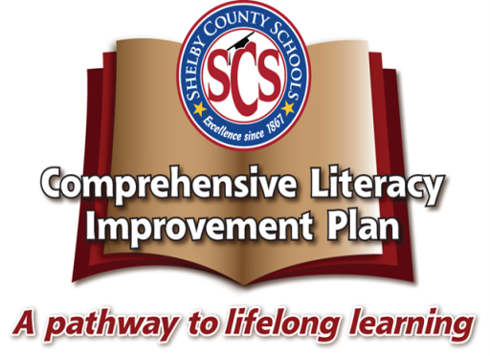

In 2014, the Shelby County Schools Board of Education adopted a set of ambitious, yet attainable goals for school and student performance. The District is committed to these goals, as further described in our strategic plan, Destination 2025. **By 2025,**

* **80% of our students will graduate from high school college or career ready**
* **90% of students will graduate on time**
* **100% of our students who graduate college or career ready will enroll in a post-secondary opportunity.**

Central to achieving these goals and Destination 2025 is the need for dramatic improvement in literacy teaching and learning to the State’s new standardsfor career and college readiness, TNCore (also called CCR or College and Career Ready standards). Our schools must ensure that *all* students have an early and strong literacy foundation (phonemic awareness, phonics, fluency, vocabulary, and comprehension), are proficient readers by 3rd grade, and continue to develop mastery throughout their education and life. The skills and knowledge captured in the literacy standards in ELA and literacy in science and technology, social studies, and technical areas are designed to prepare students for life outside the classroom. They include critical-thinking skills and the ability to closely and attentively read texts in a way that will help them understand, learn from, and enjoy complex works of literature and expository texts (from newspapers to technical manuals and textbooks) to ensure success in college, career, and life.

In particular, students must be able to read, write, and communicate about complex texts; therefore, schools and staff across content areas need to make significant shifts to:

* Regular practice with complex text and its academic language;
* Reading, writing, and speaking grounded in evidence from the text, both literary and informational; and
* Building knowledge through content-rich non-fiction.

The **Comprehensive Literacy Improvement Plan (CLIP),** the first action plan in response to Destination 2025, is designed to ensure that all Shelby County Schools (SCS) stakeholders meaningfully collaborate to support consistent, high-quality, rigorous literacy instruction for *all* PreK-12 students across the District—across schools and neighborhoods, socio-economic strata, racial/ethnic groups, native languages and English proficiency levels, academic performance levels, and abilities. The Plan acknowledges the developmental nature of literacy, draws on the District’s (both legacy Memphis City Schools’ and Shelby County Schools’) prior experiences (e.g., Early Reading First, Response to Intervention), and employs a balanced literacy approach to articulate recommended daily practice for reading and writing instruction at each grade level and across content areas.

The plan is intended to:

* Develop and sustain a shared sense of urgency about, understanding of, and commitment to improving literacy across the District;
* Articulate common expectations for literacy teaching and learning, including clarifying the non-negotiables, enabling conditions for success, and targeted best practices (based on evidence);
* Meaningfully engage students, staff, parents, and partners in shared work of improving literacy teaching and learning; and
* Ensure aligned instructional resources and systems of support, progress monitoring, and accountability—across grade-levels, content areas, schools, and district offices.

Conceived as a living document, the CLIP is expected to evolve over time, adapting to the changing needs of our students, staff (e.g., teachers, coaches, school and district leaders), families and communities and responding to new and emerging research, as well as our own experience and the availability of resources (e.g., dollars, partners, staff, expertise). Ensuring high levels of implementation fidelity and effectiveness will require both on-going collaboration and continuous improvement across staff, stakeholders, departments, and school sites. Success for our students depends on clear and consistent communication of expectations across the District across organizational levels, from the central office to principals, coaches, teachers, and the community.

The CLIP is founded on the following guiding principles and beliefs:

To that end, this document contains an overview of the CLIP for teachers and school-based staff. It is designed to ensure that all teachers understand our plan for ensuring equity in academic rigor across the District and explains our thinking about high-quality literacy instruction (including Response to Intervention) and how our supports for teachers (including the TEM evaluation system) will enable us to ensure that all students are prepred for college and career. This guide includes::

* The Need in Shelby County: the “Why” behind the CLIP
* Guiding principles and beliefs that drive our literacy work
* Vision for effective literacy instruction
* Theory of action for improving literacy teaching and learning
* CLIP early implementation priorities (for 2015-16)
* Teacher Toolkit
  + Why Text Complexity Matters
  + The Importance of Knowledge in Reading
  + The Importance of Fluency
  + Using our Curriculum Maps
  + Close Reading as a Key Strategy
  + Scaffolded Questions as a Key Strategy
  + Gradual Release of Responsibility as a Key Strategy
  + Stations as a Key Strategy
  + Response to Intervention Expectations
* CLIP “Look Fors” and instructional design by grade level
* Understanding how the CLIP and the TEM evaluation system enable us to ensure that our students achieve the CCR standards
* Crosswalk of how the TEM and the CLIP complement each other

**The Need in Shelby County: the “Why” behind the CLIP**

While reading progress in the state of Tennessee has recently out-paced the National Assessment of Educational Progress (NAEP) growth nationally, the State does not yet perform significantly differently from 17 states,and performs below 20 states. Significant achievement gaps exist across racial/ethnic groups and free/reduced price lunch-eligible and non-eligible students persist in 8th grade reading on NAEP[1]. Considerable progress is still needed to ensure all children are career and college ready.

Figure 1: TN Reading Progress on NAEP, 8th Grade (2013)

Many SCS schools are improving in literacy, including 12 that increased TCAP reading/language arts proficiency by 5 percentage points or more in 2015. In fact, despite some dips in performance, SCS literacy performance has improved over time (Figure 2), often having moderately outpaced the State in growth (e.g., English I and II in 2015).

Still, the District continues to underperform against the State’s averages in Reading/Language Arts (Figure 3); **progress is not fast enough**. In fact, at the current rate of improvement in grades 3-8 Reading/Language Arts (1.6 percentage points from 2013 to 2014), it would take until 2050 for SCS to reach 90% proficiency (Figure 4).

Figure 2: SCS Literacy Performance Over Time

Figure 3: 2015 SCS Literacy Performance by Grade

**Figure 4: Current Rate of Improvement in SCS 3-8 Reading Scores**

**33.6%**

At the same time that the District must accelerate progress in literacy learning, new TNCore standards raise the bar for what students should know and be able to do. For example, under the new standards, the level of text complexity students are expected to master to be considered career and college ready at graduation increases from the current average, national high school graduate Lexile score of 900 to 1,300. As depicted in Figure 5, new CCR standards significantly raise expectations for the level of text complexity students are expected to master at each grade level.

Figure 3: Increased Lexile Demands of CCSS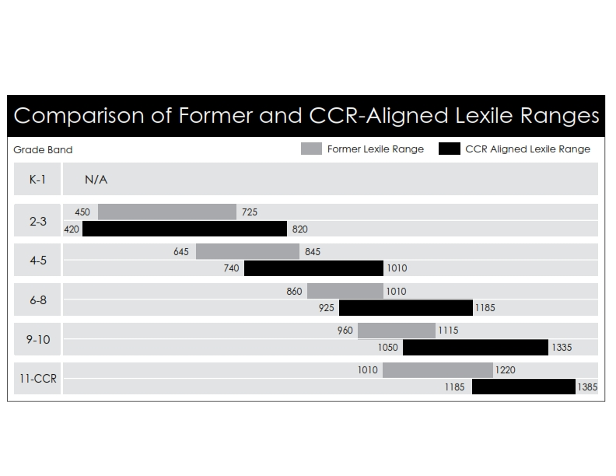

Likewise, as illustrated in the sample of standards below, the new standards demand new levels of rigor in developing higher order thinking skills (e.g., synthesis, analysis, interpretation).

Figure 4: CCSS Demands

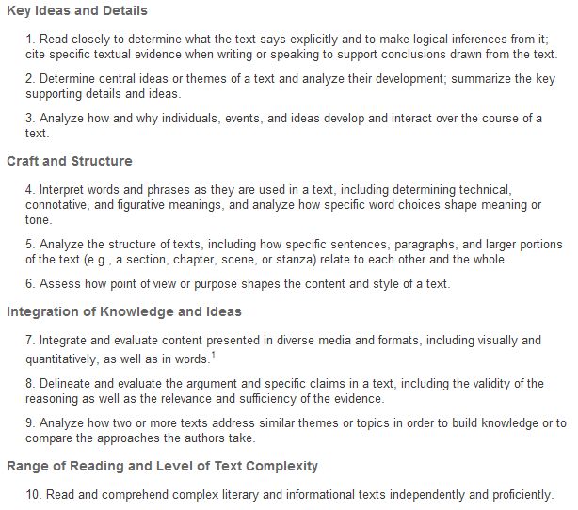

**New levels of performance to higher standards demand a new approach**. That is, given as hard as SCS students, staff, and schools are already working, working harder on our current practices will both be incredibly difficult and is unlikely to yield dramatically different results .

In fact, a variety of national studies have shown that while literacy demands and the complexity of texts have increased dramatically over the last fifty years, PreK-12 standards, curricula, and instructional materials and practices have not kept pace.

We “have not done enough to foster the independent reading of complex texts so crucial for college and career readiness, particularly in the case of informational texts. K–12 students are, in general, given considerable scaffolding—assistance from teachers, class discussions, and the texts themselves (in such forms as summaries, glossaries, and other text features)—with reading that is already less complex overall than that typically required of students prior to 1962. What is more, students today are asked to read very little expository text—as little as 7 and 15 percent of elementary and middle school instructional reading, for example, is expository (Hoffman, Sabo, Bliss, & Hoy, 1994; Moss & Newton, 2002; Yopp & Yopp, 2006)— yet much research supports the conclusion that such text is harder for most students to read than is narrative text (Bowen & Roth, 1999; Bowen, Roth, & McGinn, 1999, 2002; Heller & Greenleaf, 2007; Shanahan & Shanahan, 2008),that students need sustained exposure to expository text to develop important reading strategies (Afflerbach, Pearson,& Paris, 2008; Kintsch, 1998, 2009; McNamara, Graesser, & Louwerse, in press; Perfetti, Landi, & Oakhill, 2005; van den Broek, Lorch, Linderholm, & Gustafson, 2001; van den Broek, Risden, & Husebye-Hartmann, 1995), and that expository text makes up the vast majority of the required reading in college and the workplace (Achieve, Inc., 2007). Worse still, what little expository reading students are asked to do is too often of the superficial variety that involves skimming and scanning for particular, discrete pieces of information; such reading is unlikely to prepare students for the cognitive demand of true understanding of complex text (Common Core State Standards for English Language Arts & Literacy in History/Social Studies, Science, and Technical Subjects, Appendix A, 3).

Rather than continue to demand that individual teachers and leaders identify and solve literacy teaching and learning challenges on their own (and often by focusing on individual standards, test item types, skills and/or strategies in isolation)—with each conducting their own searches for best practices and developing their own resources, professional development, and progress monitoring supports--the CLIP calls for a more systematic approach to improvement across the District. After all, the new standards,

“demand coordination across subjects and grades to ensure that text used for instruction progresses in complexity over the course of years, develops content knowledge coherently across academic disciplines and grades, and balances literary and informational text, such that informational text comprises the majority of reading in later grades. The coherence and coordination required underscores the need for a well-defined approach to literacy instruction. Organized around the gradual release of responsibility, a comprehensive literacy framework serves as a road map to assure teachers provide all students opportunities for the modeling, guided practice, and independent practice necessary to acquire the new and higher-level skills that will allow them to master grade-level text. Comprehensive literacy frameworks create a common, consistent approach to specific instructional configurations, strategies, time expectations, and materials to be used in literacy instruction” (Brown & Kappes, 2012: 4).

Likewise, the CLIP takes a broader view of literacy. Comprehensive literacy includes the ability to read, write, speak, listen, and understand across a variety of social and academic contexts, language demands, and media. As such, literacy learning is a complex, developmental process. That is, the knowledge, skills, and dispositions required to be proficient are many, from recognizing the sound-symbol relationship between letters and decoding and spelling new words todeveloping vocabulary, reading fluently, comprehending complex texts, and writing at high levels. And these demands change over time—across grade levels, content/discipline areas, text types/genres, and the learner’s experience. Literacy learning is not like learning to ride a bike--a set of skills that do not need further development once achieved; it is an ongoing, non-linear, recursive process that requires continuing development and practice.

As described in *Reading Next’s* report on adolescent literacy,

“part of what makes it difficult to meet the needs of struggling readers and writers… is that these students experience a wide range of challenges that require an equally wide range of interventions. Some young people still have difficulty simply reading words accurately,… Most older struggling readers can *read* words accurately, but they do not *comprehend* what they read, for a variety of reasons. For some, the problem is that they do not yet read words with enough fluency to facilitate comprehension. Others can read accurately and quickly enough for comprehension to take place, but they lack the strategies to help them comprehend what they read. Such strategies include the ability to grasp the gist of a text, to notice and repair misinterpretations, and to change tactics based on the purposes of reading. Other struggling readers may have learned these strategies but have difficulty using them because they have only practiced using them with a limited range of texts and in a limited range of circumstances. Specifically, they may not be able to generalize their strategies to content-area literacy tasks and lack instruction and knowledge of strategies specific to particular subject areas, such as math, science, or history. In addition, the problems faced by struggling readers are exacerbated when they do not speak English as their first language, are recent immigrants, or have learning disabilities.” (Alliance for Excellent Education, 2004: 8).

Still others have difficulty expressing what they have read or their own thought in either spoken or written word.

Given the complex and dynamic nature of literacy development, there is no single, standard, scientific approach to its teaching. Rather, for students to be able to communicate effectively in the 21st century, they need to continuously develop the abilities to read, write, speak, listen and think critically, particularly in response to increasingly complex texts. And to do this, we must have multiple strategies and resources to respond to the diverse needs of our students. Our approach—from our texts to our assessments, instructional materials, and strategies--must be purposeful and comprehensive and it must address all elements of effective literacy programming--foundational skills, reading (including decoding, fluency and comprehension), writing, speaking and listening, language, and the integration of domains in service of learning & communication.

**Guiding Principles and Beliefs**

We believe all children can learn to high standards and our work should be focused on ensuring each child achieves to these goals. We believe:

* Teaching and learning should be aligned to the rigorous state standards for career and college readiness (CCR/CCSS), TNCore, and the instructional shifts implicit in them.
* Goals for student learning should be clearly communicated, student learning regularly and meaningfully assessed, and students (and families) receive regular feedback.
* Instruction should be differentiated to meet individual learning needs—in both core (Tier 1) and supplemental instruction.

To be successful, teachers and teacher support providers need clear expectations for performance and regular, quality feedback; high-quality instructional materials and resources (e.g., for planning and assessing); meaningful, timely and accurate data to assess student needs and modify instruction; and on-going, job-embedded professional development. We must support good first teaching and hold all accountable

We acknowledge that literacy is a continuum (from decoding and language comprehension to comprehension and deep analysis) and development varies across literacy domains (e.g., decoding, comprehension), performance levels, grades and ages, content areas, genres, and text types. Success requires articulation across grades and meaningful integration across content areas. The CLIP employs a balanced literacy approach within a Response to Intervention, 3-tier framework to ensure that all students have access to explicit, purposeful and differentiated instruction aligned to their needs. Each grade level consists of three integral components:

* Tier 1 focuses on the Core Curriculum. In this tier, literacy programs and resources, assessments, literacy block structure and instructional methods are identified along with student performance goals, best practices, and universal strategies. We expect all students to succeed; therefore we expect access to the core curriculum and good first teaching for all students, including struggling students, English language learners and students with disabilities.
* Tier 2 focuses on struggling *and* accelerated students in need of early intervention and supplemental support, in addition to core instruction.
* Tier 3 focuses on intensive intervention for our highest-need and most at-risk students. As with tier 2, programs and supports, entrance/exit criteria, and progress monitoring are provided for each identified targeted student population.

We believe literacy teaching and learning is a shared responsibility across grade levels,departments, and content areas, across schools, across organizational levels (e.g., teachers, coaches, principals, district administrators, policy makers), and with our students, parents and families, community partners, higher education, and the business community.We have a responsibility to ensure that professional development, support, and accountability are aligned to our goals and vision for literacy teaching and learning (as defined in the CLIP) and effective teacher and leadership practice more broadly (e.g., TLE and TEM).

We must continuously monitor progress, reflect, provide feedback, make improvements, and ensure meaningful support and accountability, as appropriate. On-going orgnazational learning and continuous improvement are essential .

We believe leadership matters—at all levels. Teachers, coaches, and building and district leaders must be empowered to effectively implement the CLIP with fidelity and with the needs of students at the center.

## 

## **Vision for Effective Literacy Instruction**

In CLIP and CCR-aligned literacy classrooms, **all students engage with high quality, grade level texts and tasks (in Tier 1)[2] and receive the differentiated scaffolds and support they need to do so (across tiers)**. The standards across the domains of literacy, **reading, writing, speaking and listening, and language**, are integrated to ensure all students are spending their time well and are ultimately prepared for college and career.

In CLIP and CCR-aligned classrooms, students:

* Develop **foundational skills** to put them on the path to **reading** proficiency. As needed, students receive explicit, systematic, and differentiated instruction on foundational reading skills, including concepts of print, letter recognition, phonemic awareness, phonetic patterns and word structure (decoding), fluency, vocabulary, and comprehension. Instruction on foundational skills is done in service of reading and writing, not as an end in and of itself.
* 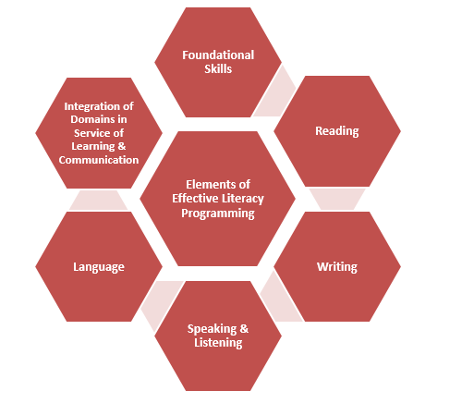Regularly read **high quality, complex texts,** strategically selected and sequenced to build students’ understanding of the world. Oral and written questions and tasks integrate the standards to help students understand the content and meaning of the text, rather than positioning the standards as the end in and of themselves.
* Produce **writing** in various forms and for a variety of purposes and audiences. Students develop logical, researched arguments that are grounded in evidence from the texts they have read and can effectively express themselves in written form.
* Engage in structured, meaningful **discussions** about texts.
* Learn about how writers and speakers make intentional choices about **language** to develop meaning. Knowledge of grammar and usage supports students’ communication and comprehension and students have an increasingly large and complex vocabulary to express their ideas.
* Work on rich tasks that **integrate these domains in service of learning and communication,** giving students the opportunity for productive struggle.

**Theory of Action for Improving Literacy Teaching and Learning**

All stakeholders have a critical role to play in empowering and supporting teachers and schools to reach our shared vision of effective instruction—as defined in the TNCore standards (and WIDA standards for English language development), the TEM rubric, and the CLIP. To provide a fully integrated literacy learning experience for students, teachers, coaches, and leaders must have access to high quality, aligned, curricular and instructional materials, assessments, and professional development. (Note: Curricular materials must be slected and applied not only in support of literacy instruction, but also to strategically build students’ background knowledge.) School leaders and teachers must take ownership over accessing and using the materials, and they must be given the time and support to understand and apply the vision of effective literacy instruction through sustained implementation support. (Dedicated time and explicit supports for students and teachers are essential.) **Each of us has a specific responsibility in implementing the CLIP and improving its impact on teaching and learning**.

Shelby County Schools is committed to this theory of action so that **every teacher will have access to strong curricular materials, aligned assessments, and high-quality professional learning aligned to the demands of the standards and the needs of their students, so that every student is proficient in literacy and is career and college ready.**

|  |  |
| --- | --- |
| **If …** | **Shelby County Schools, primarily through the Chief Academic Office, develops and implements a plan to** |
|  | * Set a clear and consistent, **districtwide vision** and **explicit expectations** for instructional time (e.g., minutes for Tier 1 literacy block, Tier 2 intervention), learning design, and effective practice (e.g., TEM). * Select **curricular materials** that reflect the demands of the standards and create high-quality **supplements and curriculum guides** that illuminate the strengths, address the gaps of adopted materials, and help staff to understand and meet expectations for scope, sequencing, and pacing. * Adopt **aligned assessments** that provide necessary data to measure students’ literacy development at each grade band and provide **effective reports and frameworks** to analyze and apply literacy data to continuously improve. * Provide **high-quality, universally accessible** **professional learning experiences** and **provide job-embedded coaching and implementation support** to support school leaders, coaches, and teachers in deeply understanding and being able to meaningfully respond to the demands of the standards to ensure that students reach those demands. * Ensure **coordinated school support** across district departments, divisions (e.g., C&I, Exceptional Children), programs, and roles (e.g., ILDs, content advisors, coaches) to provide clear, consistent, and regular communication; on-going feedback from and responsiveness to the field; and focused, strategic support (e.g., through common, short, learning cycles; targeted support to high-need schools and staff). |
| **And if …** | **Principals and instructional leadership teams lead their school communities to** |
|  | * Communicate and lead towards a **common vision**, shared commitment, and clear expectations (including for instructional minutes, instructional design, effective practice, etc.) and provide feedback to the District on the implementation of that vision and the quality of supports (and, as appropriate, contribute to the improvement of district supports). * Leverage **time and talent** (e.g., high-performing teachers, coaches) effectively to support staff and student learning. * Implement adopted curricular materials by developing **teachers’ professional judgment** in making vision-aligned planning and execution decisions. * Use available data (including student input and work samples, instructional climate data, student and teacher performance data, etc.) to make **evidence-based organizational and instructional decisions** to improve students’ ability to read, write, and communicate. * Engage in **strategic, innovative professional learning and culture-building** (including through regular formal and informal feedback, collaborative planning, school-based professional development, etc.) to ensure that all school-based stakeholders have the necessary support and space to change their instructional practices in alignment with the literacy instructional vision, CCR demands, and TEM standards. |
| **And if …** | **Teachers are positioned to** |
|  | * Receive and provide regular feedback (e.g., to colleagues and school and district leaders), and engage in a variety of high-quality, professional learning experiences that honor the **time and space necessary to change their instructional practices** and implement the standards and literacy instructional vision with fidelity (and, as appropriate, contribute to the improvement of school and district supports). * Ensure appropriate instructional time and focus (e.g., time on task) to implement the literacy instructional vision with fidelity and provide students the support (e.g., explicit literacy instruction) they need. * Exercise **well-developed professional judgment** to effectively leverage texts, supplementary materials, and instructional resources (e.g., pacing guides). * Leverage high-quality data to make evidence-based decisions to appropriately **differentiate scaffolds and supports** in order to develop students’ ability to read, write, and communicate. |
| **Then we will…** | **Ensure effective literacy instruction that prepares students for success in college and career in all SCS classrooms.** |

## Over the course of the next few months, the District will continue to roll out new and revised curriculum materials, teacher resources, assessments, and professional development so that we can work together to accelerate literacy teaching and learning in all SCS classrooms and schools, and for all students.

## **Putting the Pieces Together to Achieve Destination 2025**

To reach the ambitious goals outlined in Destination 2025, students must be exposed to rigorous content that is aligned to the College and Career Ready standards, and teachers must teach that content in such a way that students can successfully engage with the type of rigorous thinking they will be expected to do in their college and careers. In short, we must support our teachers to know **what to teach**, as well as **how to teach it** (including both instructional practices and text selection and sequencing/pacing to ensure the strategic development of students’ background knowledge over time).

We have strong and exciting plans in place to ensure that we meet Destination 2025. First, we have the **TNCore and WIDA standards**, which name the content that our students must master in order to be college and career ready. These standards define what students need to know and be able to do and show teachers **what to teach** at each grade level**.**

Students master CCR content because teachers’ lessons meet our vision for effective literacy instruction.

**COMPREHENSIVE LITERACY IMPROVEMENT PLAN**

2025v

**80% of seniors will be college or career-ready.**

**90% of students will graduate on time.**

**100% of CCR graduates will enroll in a post-secondary opportunity.**

**TNCORE STANDARDS**

Students learn the most important content because teachers know what content to teach in order to put students on a college and career ready path.

**TEM EVALUATION SYSTEM**

Students master the CCR content because teachers deliver lessons well, in alignment with the TEM evaluation system.

Second, we have a strong **TEM Evaluation System** that articulates a common vision for effective instruction, helps teachers to plan, provides feedback to teachers on **how to teach** and **how effectively they are teaching,** and helps guide school leader and coach support

Finally, we have the **Comprehensive Literacy Improvement Plan** (and aligned Look Fors) that outlines **our vision for effective literacy instruction** and lays out a clear path to ensure that we have a CCR-aligned vision and the curricular and instructional materials, assessments, and professional development supports to ensure that we are all driving towards high levels of literacy learning.

The TEM Evaluation System and the Comprehensive Literacy Improvement Plan are intended to work together[3] to ensure that our students are able to reach the College and Career Ready standards. Ensuring that our teachers know what to teach and how to teach it in alignment with our vision for effective literacy instruction will better position us to reach **Destination 2025,** dramatically transforming the educational experiences and opportunities of students in Shelby County Schools.

***Response to Intervention***

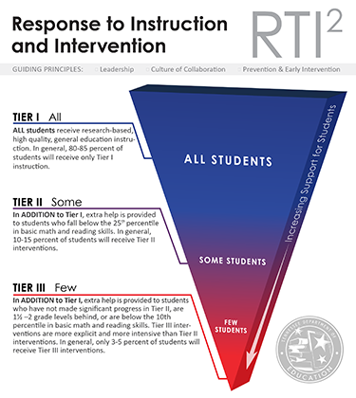SCS is dedicated to preparing ALL students for success in college and/or career l. Response to Instruction and Intervention is designed to ensure *every*student the opportunity to meet high expectations and the support to reach them. CLIP leverages this three-tiered system to better differentiate student support. While early the early CLIP implementation focus (e.g., targeted instructional design, early look fors) focuses on improving Tier 1, core instruction,  the overall plan will address not only “good first teaching,” but also targeted intervention and progress monitoring across levels.

***Universal Screening***

Three times per year, a nationally normed, skills-based universal screener of academic skills is administered to ALL students to determine whether students demonstrate the skills necessary to achieve grade-level standards. This universal screening is used to identify students in need of further intervention due to identified skill deficits.

***Tier I Supports***

Tier 1 focuses on the Core Curriculum. In this tier, literacy programs and resources, assessments, literacy block structure and instructional methods are identified with student performance goals, best practices, and universal strategies. Enrichment is provided through differentiated instruction.

***Tier II Interventions***

Students who score between the 24th and 11th percentile on universal screening are considered “at risk” and unlikely to respond to Tier I supports alone. As needed, a more precise assessment is completed to determine a student’s specific area(s) of deficit before beginning an intervention. Current intervention methods for literacy skill weaknesses in Tier II include explicit, systematic instruction in small groups in collaboration with computer-based intervention programming. Interventions are skill specific and matched to meet the needs of each student based on results of continuous progress monitoring.  Interventions occur 5 times a week for 30 minutes per day in addition to the core curriculum.

Progress monitoring occurs at least every other week and occurs in the targeted skill deficit area to ensure adequate progress and learning. The intervention is conducted by the classroom teacher, a specialized teacher, or an external interventionist. The intervention should occur while the other students are engaged in an enrichment activity or during a separately enrolled course.

***Tier III Interventions***

Students at or below the 10th percentile receive intensive, Tier III intervention. Tier III intensive intervention services include many of the supplemental services provided in Tier II but with increased frequency/intensity and/or duration.  In Tier III, interventions occur 5 times a week for at least 45 minutes per day in addition to the core curriculum.

Progress monitoring occurs weekly and occurs in the targeted skill deficit area to ensure adequate progress and learning. The intervention is conducted by the classroom teacher, a specialized teacher, or an external interventionist. The intervention should occur while the other students are engaged in an enrichment activity, Tier II intervention, or during a separately enrolled course.

***English Language Learners***

A student is identified as an English Language Learner (ELL) if a child’s parent or guardian selects any answer besides English on the Home Language Survey. All ELLs are screened with an English Language Proficiency Assessment to determine English language fluency and complete the same skill and grade-based Universal Screener as non-ELLs to determine literacy skill level.

ELL students who fall below the 25th percentile on the universal screener and have not acquired Intermediate Fluency based on the English Language Proficiency Assessment receive research-based and rigorous ESL services. ELL students who fall below the 25th percentile on the universal screener and have acquired Intermediate Fluency based on the English Language Proficiency Assessment receive RTI² interventions in their specific area of need.

An ESL teacher is part of the school level RTI²team when an ELL is being placed in or moved out of an intervention or when discussing the need for a parent meeting.

## **CLIP Early Implementation Priorities (2015-2016)**

Ensuring that our students are able to achieve to new , more rigorous standards for career and college readiness will take time, especially given both the multiple risk factors they face and the significant changes in instructional practice needed to effectively respond to their needs and the shifts demanded by TNCore. The Look-Fors were developed to help guide changing practice—as reminders of the new expectations to be used to help teachers plan and reflect and coaches and leaders monitor progress and provide support and feedback. The complete list of Look Fors (by grade band) can be seen here.

However, given the nature of any change process, that accountability should generally not out pace articulation of and support for meeting new expectations. Meaningful change takes time—even to get good at a just a few things, so we do not expect full implementation, with fidelity, on all aspects of the literacy vision, at scale, over night. However, early, demonstrable progress is urgently needed and immediately expected to ensure that our students are on track to Destination 2025. Teachers, caoches, and school and district leaders are expected to be focused on and implementing CLIP-aligned instruction on Day 1 and every day.

As outlined [in *Lasting Impressions: Targeted Learning Plan has a Maximum Impact on Teacher Practice*](http://www.literacyinlearningexchange.org/sites/default/files/nelsen305.pdf)*,* schools can only reasonably expect to build true expertise in a few instructional practices at a time. Given the fact that teachers and schools cannot fully implement the significant instructional shifts required by the TNCore standards overnight, the District has prioritized key Look Fors that are foundational to effective literacy instruction.

To help pace the change process and support a coordinated, district-wide focus on a few key implementation areas at a time, the District has articulated a few priorities for early CLIP implementation. As appropriate, district-provided professional development and support for teachers, coaches, school leaders, and central office staff will be aligned to the following Look Fors throughout the course of the year. Coaches, school leaders, and other school support providers are expected to understand, reinforce, support, and provide explicit feedback in these priority areas. Of course, some schools and staff will progress more quickly and meaningfully than others, and school leadership teams are expected and trusted to make additional decisions about pacing and support as needed.

|  |  |  |  |  |  |  |  |  |  |  |  |
| --- | --- | --- | --- | --- | --- | --- | --- | --- | --- | --- | --- |
| **SUMMER 2015** | | | | **FALL SEMESTER 2015** | | | | **SPRING SEMESTER 2016** | | | |
| **May** | **June** | **July** | ***August*** | **September** | **October** | **November** | **December** | **January** | **February** | **March** | **April** |
| **Rituals and Routines:** The teacher provides the conditions for all students to focus on the text, and students clearly know the routines and procedures in the classroom. | | | | |  | | | | | | |
| **Foundational Skills Materials and Instruction Explicitly and Systematically Provide All Students with the Opportunity to Master Foundational Skills:** Our elementary teachers are able to use the provided *Journeys* foundational skills materials to ensure:   * The foundational skills being taught are aligned to the standards for the grade. * Instruction and materials address foundational skills by attending to phonological awareness, concepts of print, letter recognition, phonetic patterns, and word structure. * Instruction and materials provide sufficient opportunities for all students to practice reading and writing using newly acquired foundational skills. * Instruction and materials connect acquisition of foundational skills to making meaning from reading. * Instruction and materials provide opportunities for students to demonstrate understanding of the skills being taught through frequent monitoring of student progress. | | | | | | | | | | | |

|  |  |
| --- | --- |
| **Core Action 1: Focus Each Lesson on a High-Quality Text or Multiple Texts:** Our teachers will be able to focus each lesson on a high-quality text, ensuring that:   * A majority of the lesson is spent reading, speaking, or writing about high quality texts. * The text(s) are at or above the complexity level expected for the grade and time in the school year. * The text(s) exhibit exceptional craft and thought/or provide useful information. * Texts are selected strategically to develop a coherent body of knowledge. |  |
|  | **Core Action 2: Employ questions and tasks that are text dependent and text specific.** Our teachers will be able to employ questions that are text dependent and text specific, ensuring that:   * Questions and tasks address the text by attending to its particular structure(s), concepts, ideas, and details. * Questions and tasks require students to use evidence from the texts to demonstrate understanding and to support their ideas about the text. These ideas are expressed through a variety of means. * Questions are sequenced to build knowledge by guiding students to delve deeper into texts and graphics. |

**Teacher Toolkit**

This section of the CLIP Teacher Overview is intended to provide teachers with information about key ideas and strategies to ensure that their students are prepared to meet the demands of the TNCore standards. This section is meant as an introductory summary; teachers and school staff are expected to seek out additional resources and supports as needed to ensure that literacy achievement increases significantly. This might include pulling resources from the Student Achievement Partners website or the TNCore website, attending targeted professional development after registering through MLP, or studying exemplar classroom videos from TeachScape or the Teaching the Core website.

The Teacher Toolkit is split into two sections: An Integrated Approach to Literacy and Lesson Design.

An Integrated Approach to Literacy

***An Integrated Approach to Literacy***

To reach the demands of the TNCore standards (and WIDA-aligned expectations for language development) and truly become college and career ready readers, writers, and communicators, teachers must integrate the literacy domains in service of learning and communication, as detailed in Appendix A of the Common Core State Standards[4]. Teachers must ensure that students:

* **Develop **foundational skills** to put them on the path to **reading** proficiency. As needed, students receive explicit, systematic, and differentiated instruction on foundational reading skills, including concepts of print, letter recognition, phonemic awareness, phonetic patterns and word structure (decoding), fluency, vocabulary, and comprehension. Instruction on foundational skills is done in service of reading and writing, not as an end in and of itself.
* Regularly read **high quality, complex texts,** strategically selected and sequenced to build students’ understanding of the world. Oral and written questions and tasks integrate the standards to help students understand the content and meaning of the text, rather than positioning the standards as the end in and of themselves.
* Produce **writing** in various forms and for a variety of purposes and audiences. Students develop logical, researched arguments that are grounded in evidence from the texts they have read and can effectively express themselves in written form.
* Engage in structured, meaningful **discussions** about texts.
* Learn about how writers and speakers make intentional choices about **language** to develop meaning. Knowledge of grammar and usage supports students’ communication and comprehension and students have an increasingly large and complex vocabulary to express their ideas.
* Work on rich tasks that **integrate these domains in service of learning and communication,** giving students the opportunity for productive struggle.

***Why Text Complexity Matters***

In 2006, the American College Testing (ACT) Service published an influential study entitled *Reading Between the Lines[5]* in which it analyzed student responses to determine what patterns might distinguish students scoring above their college ready reading benchmark from those who score below that threshold. They determined that:

* Literal versus inferential question types failed to differentiate students scoring above the benchmark from those scoring below .
* Question types focused on textual elements (i.e. main idea, supporting details, generalizations and conclusions, etc.) also failed to differentiate students scoring above from those scoring below.
* The clearest difference of performance between the two groups was the the *degree of text complexity* of passages that students could successfully read.

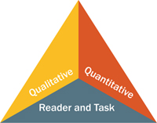This is a “stunning finding,” as educators have traditionally thought of “critical thinking” as the thing that separates college and career ready students from their peers who are not yet college and career ready. This study shows that “critical thinking does not dinstinguish those who are college and career ready from those who are not; facility with reading complex text does” (Liben).. Multiple studies have demonstrated that primary and secondary school texts have gotten easier across time while college textbooks have not gotten any easier and in fact, have increased in difficulty as measured by Lexile points (Liben). As educators, we nee to do more to ensure that our students have more regular and meaningful practice with complex texts; their first exposure should not be on standardized assessments.

These findings caused the writers of the College and Career Ready (Common Core) standards to articulate a three-part model for determining text complexity and to specify that text complexity should increase grade by grade, as outlined in TNCore reading anchor standard 10. We can determine text complexity by considering the **quantitative measures**, **qualitative measures**, and **reader and task considerations** of a text (as outlined in Appendix A of the Common Core standards). The standards presume that all three of these measures will come into play when determining whether a text is appropriately complex for particular students.

To determine whether a text is appropriately complex, consider each of the three measures of complexity as outlined in Appendix A[6] of the standards.

**Step 1: Measure quantitative complexity.** First, consider the quantitative complexity of a text with the purpose of making sure that the text meets the (updated) quantitative demands of the standards as outlined in the following chart:

|  |  |
| --- | --- |
| Grade Bands | Lexile Levels Appropriate for the Grade Band |
| 2nd -3rd | 420-820 |
| 4th – 5th | 740-1010 |
| 6th – 8th | 925-1185 |
| 9th 10th | 1050-1335 |
| 11th – CCR | 1185-1385 |

To determine the Lexile level of a given text, use the following tool:

|  |  |  |
| --- | --- | --- |
| **The Lexile Framework®** – Metametrics | <http://www.lexile.com/analyzer/> | Before using the Lexile Analyzer, remember that you may be able to find the Lexile for your text through the *Quick Book Search* tool on [www.lexile.com](http://www.lexile.com).  If you need to run a text through the Lexile Analyzer, follow these simple steps to prepare the text:   1. Create an account at [www.lexile.com](http://www.lexile.com) by answering a few simple questions. Once logged into your account, scroll down to *My Tools*. Under the tools you can access, click *English Lexile Analyzer.* 2. Copy and paste original text (up to 1000 words) into a Word document. Eliminate any extraneous information other than the passage, title, and author. Delete any tables, graphs, or other illustrations. Make the text a uniform font, size, and paragraph scheme (single spacing, no spaces after paragraphs, etc.). Save file as .txt file with ASCII character encoding. Be sure to check the *Allow Character Substitution* box. 3. Close Word and open newly saved .txt file using TextEdit or Notepad. Proofread text for typos. Eliminate any non-ASCII characters ("curly" quotation marks, em dashes, question marks that took the place of apostrophes, etc.). Re-save newly scrubbed file as a .txt file. 4. Upload the prepared text file and run the quantitative analysis. Use the results and the Lexile chart from the standards, or the one include below, to determine the suggest grade band for the text. |

After a teacher determines the complexity level of the text, it is recommended that he/she select a grade band in which to place the text to move forward in determining the qualitative complexity of the text. As one example, if the Lexile level of *The Lottery* by Shirley Jackson was 1310L, we could place that text is the 9-10 band (as the range of the 9-10 band is 1050-1335).

**Step 2: Measure qualitative complexity.** After measuring the quantitative complexity, consider how qualitatively complex the text is. As outlined in Appendix A of the standards, “using qualitative measures of text complexity involves making an informed decision about the difficulty of a text in terms of one or more factors discernible to a human reader applying trained judgment to the task” (5). Appendix A defines qualitative complexity in the following way:

Built on prior research, the four qualitative factors described below are offered here as a first step in the development of robust tools for the qualitative analysis of text complexity. These factors are presented as continua of difficulty rather than as a succession of discrete “stages” in text complexity. […] Few, if any, authentic texts will be low or high on all of these measures, and some elements of the dimensions are better suited to literary or to informational texts.

**(1) Levels of Meaning (literary texts) or Purpose (informational texts)**. Literary texts with a single level of meaning tend to be easier to read than literary texts with multiple levels of meaning (such as satires, in which the author’s literal message is intentionally at odds with his or her underlying message). Similarily, informational texts with an explicitly stated purpose are generally easier to comprehend than informational texts with an implicit, hidden, or obscure purpose.

**(2) Structure.** Texts of low complexity tend to have simple, well-marked, and conventional structures, whereas texts of high complexity tend to have complex, implicit, and (particularly in literary texts) unconventional structures. Simple literary texts tend to relate events in chronological order, while complex literary texts make more frequent use of flashbacks, flash-forwards, and other manipulations of time and sequence. Simple informational texts are likely not to deviate from the conventions of common genres and subgenres, while complex informational texts are more likely to conform to the norms and conventions of a specific discipline. Graphics tend to be simple and either unnecessary or merely supplementary to the meaning of texts of low complexity, whereas texts of high complexity tend to have similarly complex graphics, graphics whose interpretation is essential to understanding the text, and graphics that provide an independent source of information within a text. (Note that many books for the youngest students rely heavily on graphics to convey meaning and are an exception to the above generalization.)

**(3) Language Conventionality and Clarity**. Texts that rely on literal, clear, contemporary, and conversational language tend to be easier to read than texts that rely on figurative, ironic, ambiguous, purposefully misleading, archaic or otherwise unfamiliar language or on general academic and domain-specific vocabulary.

**(4) Knowledge Demands**. Texts that make few assumptions about the extent of readers’ life experiences and the depth of their cultural/literary and content/discipline knowledge are generally less complex than are texts that make many assumptions in one or more of those areas (5).

The authors of the standards developed two rubrics (one for literary texts, one for informationl texts) intended to help teachers make decisions about the complexity of the texts that they are teaching. You can see those rubrics on pages 22 and 23 of this documentThe literary text rubric is applied on page 24 of this document, when Shirley Jackson’s *The Lottery* is analyzed.

During this step, teachers also consider text maturity. As one example, *The Grapes of Wrath* by John Steinbeck has a Lexile score of 680, as Steinbeck consistently uses simple language and dialogue as a stylistic choice. If teachers determined a grade band in which to place *The Grapes of Wrath* solely based on its Lexile score, second and third graders around the country would be reading about the Joads. However, the levels of meaning and knowledge demands of *The Grapes of Wrath*, as well as some of its more mature themes and scenes, cause it to be ideal for reading with 9th and 10th graders.

**Step 3: Analyze the reader and task considerations.** After considering the qualitative and quantitative measures, teachers should also consider their readers and the task they would put in front of them while making decisions about how to teach a given text. Teachers should consider the following questions when thinking about their readers and the task with which students would engage with as they read a given text:

**Guiding Questions before Fully Analyzing a Text:**

* Does engagement with this text make sense given my current instructional aims?
* Is the content of this text appropriate for the age of my students?
* Will engaging with this text build my students knowledge of the world?

*If the answer to either of these questions is no, then it is not an appropriate text selection.*

**Guiding Questions after Analyzing Qualitative and Quantitative Measures:**

* **Essential Understandings:** What are the big ideas I want my students to take away from this piece?
  + Use the answer to this question to help you confirm that the content of the piece is age appropriate and will build your students understanding of the world, and to help you plan your questions for the text strategically.
* **Desired Outcomes:** What are three to four CCSS that I want to address using this piece of literature? What grade-level standards best represent the type of thinking I would want students to do about this piece?
  + Use the answer to this question to identify which grade-level CCSS will be the focus of instruction of the text and the content of questions about the text.
* **Your Readers:** Based on a clear understanding of each student’s reading ability, prior knowledge, and motivation, what aspects of the text will likely pose the most challenge for my students?
  + Use the answer to this question to guide the design of your instructional supports so that all students (even those who struggle with reading) are able to access the text independently and proficiently through multiple readings of the text.
    - Consider: Read aloud, read along, read alone
    - Consider: Vocabulary supports
    - Consider: Additional readings to build context or background knowledge
* **Your Unit:** How can this text be used with other texts?
  + Use the answers to determine how this text “fits” within a larger unit of instruction (e.g., Can the text serve as an “anchor” text connected to other shorter texts? Does the text require background knowledge that can be learned by reading other texts?)

Teachers answer these questions as they plan to use a given text, as it enables them to determine the best way to ensure that students can make sense of a high-quality, grade-level appropriate text. There is a model of this type of thinking on page 25 of this document, when Shirley Jackson’s *The Lottery* is analyzed.

Teachers can use the text complexity analysis template on pages 26 and 27 of this document to conduct the analyses of texts that they are considering selecting for their class.

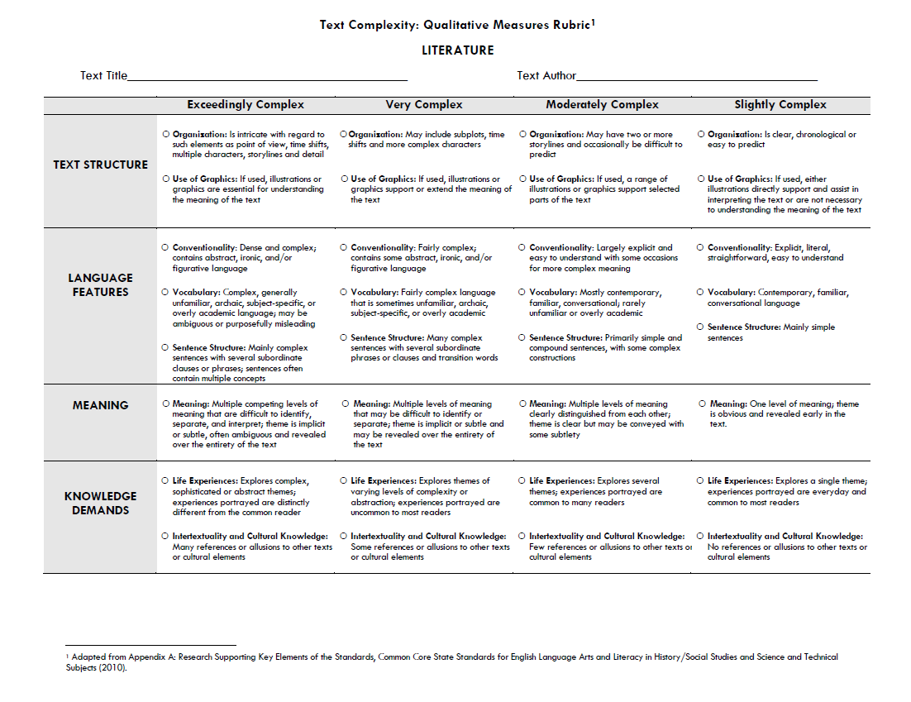

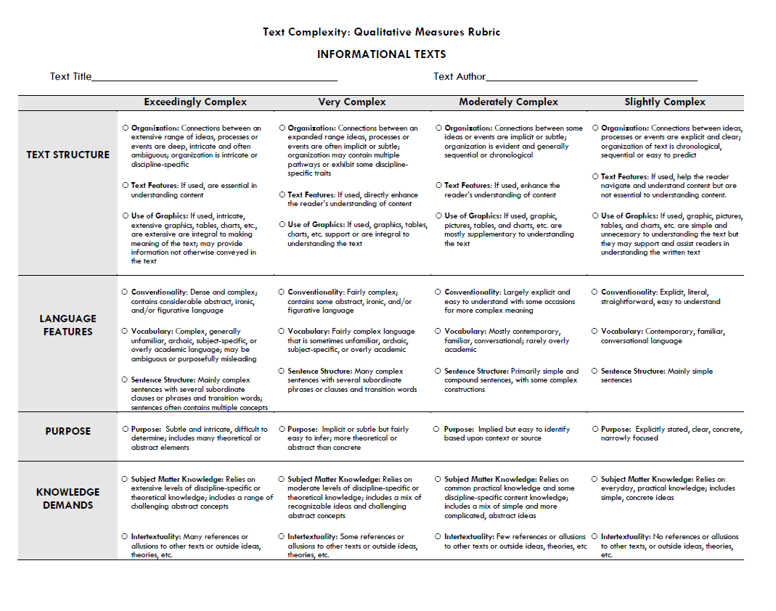

**Text Complexity Analysis of***The Lottery* by Shirley Jackson



**Text Type: Literature**

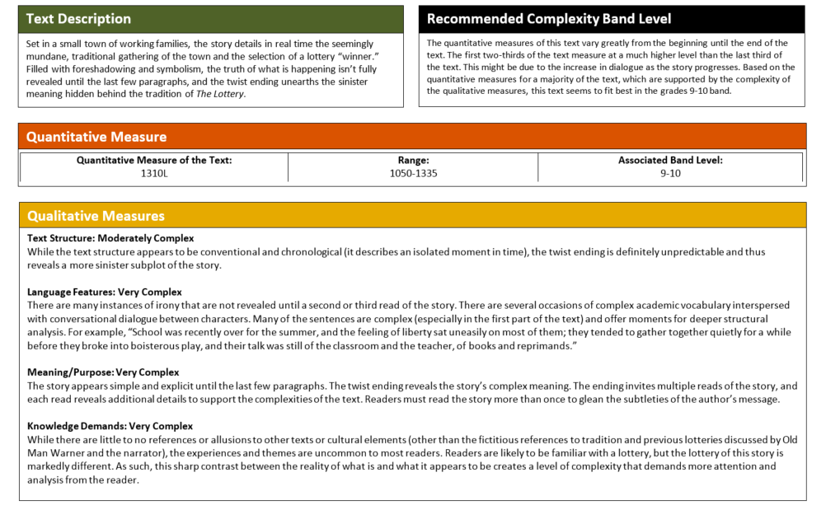

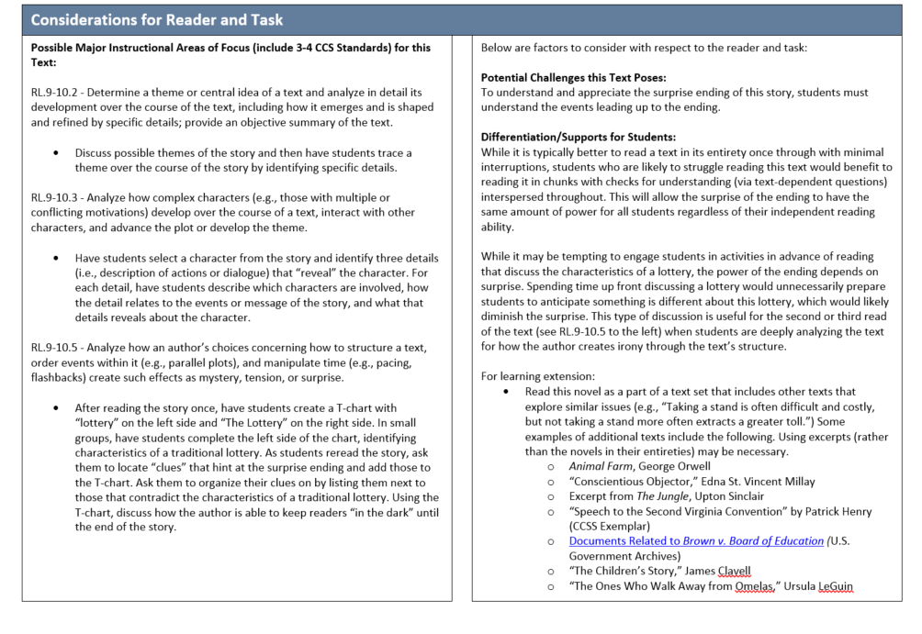

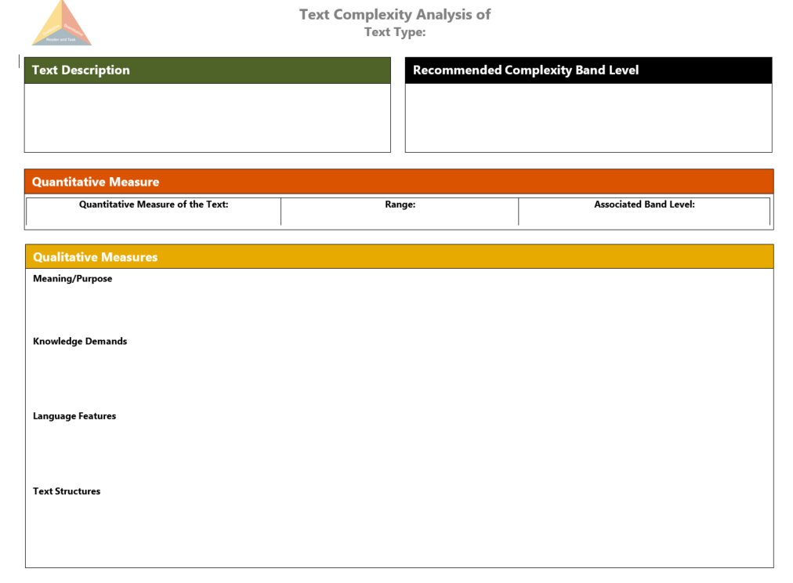

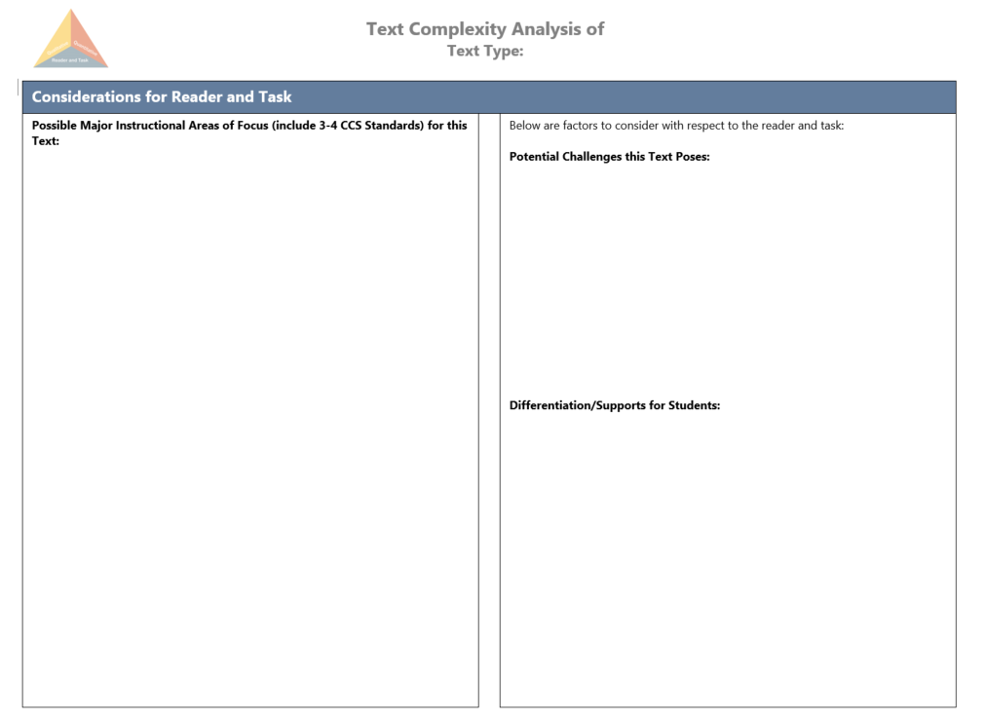

***The Importance of Vocabulary in Reading***The TNCore and WIDA standards place a premium on building students’ vocabulary because, as David Liben outlines in *The Significance of Vocabulary in the Common Core State Standards: An Overview of the Research Base and Instrutional Implications[7]:*

Vocabulary has been empirically connected to reading comprehension since 1925 (Whipple 1925, NRP 2000, Snow 2002), and most recently in results from the 2009 and 2011 NAEP (NCES 2012). Yet, vocabulary instruction is neither frequent nor systematic in most schools across the country (Durkin 1979, Scott and Nagey 1997, Biemiller 2001).[8] For decades, vocabulary instruction has been ill-defined in state standards and assessments, as well as in core reading programs (Hiebert 2009, Marzano et al 2005, Biemiller 2005, Nagy et al 1989, Nagy and Scott 2000).

The Common Core State Standards (CCSS) place a premium on vocabulary in the reading, writing, and speaking and listening strands. Anchor reading standard 10 requires students to “read and comprehend complex literary and informational texts independently and proficiently” while reading standard 4 and language standards 4,5, and 6 all call for emphasis on vocabulary and word awareness at every grade level. We know that of the many features of complex text, difficult or uncommon vocabulary likely plays the largest role in causing student difficulty (Nelson *et al* 2012). We also know vocabulary is one of the primary causes of the achievement gap (Becker 1977, Baumann & Kameenui 1991, Stanovich 1986), and many students from low-income households enter school with smaller vocabularies than their more affluent peers (Hart and Risley 1995, Biemiller 2010). For all of these reasons, vocabulary instruction in the era of the CCSS needs to be more systematic, intensive, and efficient than it has been to date. Fortunately, there is already some evidence this is happening (Beck and McKeown Webinar 2012).

## **Instructional Implications**

So how do we teach the volume of words and phrases necessary for students to read grade-level text independently and proficiently and such that students developa deep understanding that they can apply across contexts?

Until relatively recently, debates about how to teach vocabulary centered on direct instruction versus learning from context through wide reading. Advocates for the context approach pointed to the number of words students need to learn as being impossible to teach directly within the school day, week, or year. Thus, emphasis needed to be placed on wide reading. This was the origin of the “25 books a year programs” prominent in the mid 1990’s and still present in some states’ standards. Direct instruction advocates argued that a focus on growing “word awareness” through instruction was essential.

The debate has been settled with a body of work showing that not all words are created equal (Nagy et al 1985, Cunningham and Stanovich 1988, Baker et al 1995, Beck et al 2002, Biemiller 2004, Moats 2005). Some words and classes of words appear far more frequently in texts students read. Learning these particular words makes students more likely to learn other words independently from context; this effect is strengthened if instructional methods are research-based (Nagy and Hiebert 2007, Moats 2005, Beck et al 2002, Snow 2007). Thus, teaching words directly enhances student capacity for learning from context: the more words a student knows, the more likely she is to be gathering new meanings from context. This is even more likely with words that appear in a wide range of text types and are expected to be seen frequently by the student reader. Thus, both methods—direct instruction and learning vocabulary in context—are necessary components of vocabulary instruction.

The true challenge comes in choosing exactly which words to teach, how to teach them, and how long to spend on them. Hiebert (2009) describes three general criteria for determining which words to choose for intensive teaching:

1) words needed to fully comprehend the text,

2) words likely to appear in future texts from any discipline, and

3) words that are part of a word family or semantic network.

These criteria serve as useful guideposts, but truly knowing when to stop and teach in context, when to prepare students in advance, and when to teach words more intensively, is challenging for even the most seasoned educators. In preparing a text for instruction, teachers frequently find themselves asking, “Which words do I teach, and how much time do I give to them?”

Words that can be quickly explained should be explained in the moment of encounter. This often includes:

1. concrete words,
2. words with single meanings, and
3. words reflecting meaning or shades of meaning that are likely already part of the students’ experiences.

The explanation will enhance and not impede comprehension because it will be swift and unobtrusive (Biemiller 2010).

Words that need more explanation will ideally be taught in context, and then reinforced after, as these explanations will be more elaborate and time-consuming (Beck, McKeown and Kucan 2007, Biemiller 2007). This includes

1. words that are abstract,
2. words with multiple related meanings, and
3. words reflecting meanings or shades of meaning that are likely not part of the students’ experiences.

Understanding how words are classified into tiers can help educators plan effective vocabulary instruction. Text can be broken down into three tiers of words (Beck and McKeown 2002), each with its own implications for instruction:

**Tier one words** are the words of everyday speech usually learned in the early grades or at home, though not at the same rate by all children (Biemiller 2007). These words are extremely important to early learning since teachers tend to use these very words to define more unusual words. Because they are learned largely through conversation, and are not often considered challenging beyond the early grades, students who don’t in fact know them can easily be left behind. Biemiller’s work shows that though many students learn these words in the elementary years, lower income students tend to learn them later. This delays these students’ vocabulary growth and makes catching up to their more affluent peers extremely difficult if teachers are not alert to this phenomenon.

**Tier two words** are “words [or phrases] that characterize written and especially academic text—but are not so common in everyday conversation” (Beck, McKeown, and Kucan 2008). Tier two words appear in all sorts of texts: academic texts (*relative, vary, formulate, specify, accumulate*), technical writing (*calibrate, itemize, structure*), and literary texts (*misfortune, dignified, faltered, unabashedly*). Tier two words are far more likely to appear in writing than in speech. The Standards refer to tier two words as ***academic vocabulary.***

These words require particular instructional attention. They are often vital to comprehension, will reappear in many texts, and are frequently part of word families or semantic networks. The challenge to teachers is to be alert to the presence of tier two words, determine which ones need to be taught, and which words deserve more time and attention for richer understanding. Tier two words can carry disproportionate weight in conveying the meaning of a text, and a reader who doesn’t understand even a single such weighty word might have his or her comprehension thrown off track. This is equally true of informational and literary texts. It is for these reasons that the Common Core State Standards for ELA / Literacy demand significant instructional attention to these words.

Instruction of tier two words might begin with careful examination of the key role these words play in the text, followed by examining the variety and shades of meaning each of these words possesses. This, in turn, would be followed by careful attention to the spelling and pronunciation, as well as any prefixes, suffixes and roots, i.e. the morphology or structure of the word. This focus on precise meanings in varied contexts combined with morphology will also provide some of the repetitions necessary for learning the word. Encounters with a word spread out over time will further increase the likelihood of retention.

**Tier three words** are far more common in informational passages than in literature. They are specific to a domain or field of study (*lava, fuel injection, legislature, circumference, aorta*) and key to understanding a new concept within the text. Because of their specificity, tier three words are often explicitly defined by the text and repeatedly used. Thus, the author takes care to have the text itself provide much support in the learning of tier three words. In addition, as they are the words that contain the ideas necessary to a new topic, teachers often define and reinforce tier three words prior to and after students encounter them in a text. Therefore, students’ acquisition of tier three words is generally taken good care of by teachers as they know that the student has likely not encountered these terms before.

Now that we’ve examined tier two and three vocabulary, let’s take a look at how we identify these words within a text passage. Immediately following the works cited of this paper is a vocabulary exercise that asks you to practice identifying tier two and three words in passages from Appendix B of the CCSS. The exercise includes both an informational passage and a literary passage for each of the following grade bands: 4-5, 6-8, 9-10, and 11-12. There are clean copies of each passage included so that this activity can be used for professional learning if desired. The model responses provide discussion around which words I selected and why, as well as how much time one might spend on instruction of different words. These examples may serve to make the ideas discussed in this paper more concrete.

It is important to note the very high number of words recommended for instruction in these passages, more than many of us have been used to teaching. This reflects the importance of vocabulary to comprehending complex text as called for by the CCSS. Students who are behind need to learn more words. This can only happen if we all make vocabulary and word study a priority in our materials and instruction. This means we must become comfortable with teaching word meanings efficiently; devoting more time and attention to those words that merit it, and less to those that can be learned with less time and attention[9].

***The Importance of Knowledge in Reading***

The College and Career Ready standards do not simply demand that students read more informational text; they demand that students “build knowledge by reading content-rich non-fiction.” As outlined by the writers of the standards in *Three Core Shifts to Deliver on the Promise of the Common Core State Standards in Literacy and Math[10]:*

The evidence is strikingly clear that reading content-rich nonfiction about history, social studies, science and the arts in elementary school is critical for later reading growth and achievement. Research shows that students need to be grounded in information about the world around them in order to develop a strong general knowledge and vocabulary that is necessary for becoming a successful reader. However, today students read overwhelmingly stories in elementary school; on average, less than 10 percent of elementary ELA texts are nonfiction.[11]

To be clear, literature plays an essential role in cultivating students’ reading skills and developing their love of reading, and the Standards celebrate the role literature plays in building knowledge and creativity in students. The Standards therefore strongly recommend that all students equally read rich literature in elementary school as well as content-rich nonfiction. In later grades, the Standards empower history, social studies, and science teachers to equip students with the skills needed in college to read and gain information from content-specific nonfiction texts.

The Standards emphasize careful reading—the close rereading of texts to ensure understanding—so the quality of texts that student encounter also matters. To become prepared for career and college, students must wrestle with a wide variety of high quality texts from across diverse genres, cultures, and eras. These excellent texts model for students the type of thinking and writing that they should aspire to in their own work.[12]

Much research since the 1980s has demonstrated that a reader’s knowledge about a particular topic plays a significant role in whether or not the reader can comprehend a given text[13]. This means that as teachers, **we must sequence texts so that they build students’ knowledge of the world** rather than simply giving students lots of different informational texts about disparate topics.

***The Importance of Fluency***

As David LIben, who in an author of the Common Core standards, stated[14], “Fluency does not gurantee comprehension, but a lack of fluency gurantees almost all the time a lack of comprehension, especially with more complex text.” As outlined in *‘Both and’ Literacy Instruction K-5: A Proposed Paradigm Shift for the Common Core State Standards ELA Classroom[15]:*

To assure that all young readers achieve reading fluency, well-developed materials need to provide frequent and differentiated opportunities for students to practice oral reading and receive feedback. For at least the next several years of transition to CCSS, reading fluency will be an issue for many students up and down the grades since much of what is being read is the more complex text called for by the CCSS (Benjamin and Schwanenflugel, 2010). Students also need to be given the opportunity to listen to fluent reading while following along in the text and “reading in their head” (Chard, et al 2002). The emphasis on fluency instruction must include expression (prosody), as well as accuracy and a chance to develop one’s own sense of a reading rate appropriate to the text being read. All of this must be clearly and strongly connected to comprehension. Practicing to read fluently offers an authentic opportunity to apply a broad range of cueing systems facile readers use automatically: grapho-phonemic, semantic and syntactic clues are all taken in during the course of proficient reading. To ensure all students are getting the chance to become fluent, there need to be several more elements folded into a ‘both and’ literacy classroom. There needs to be a way for teachers to systematically assess fluency, the program needs to have systems for teachers to monitor those results, and it needs to provide all students with the opportunity, the time and the attention needed to become fluent. Not as an end in itself, but as a necessary precursor to independent reading success.

A strong reading foundation is the essential bedrock students need to access for themselves the world of knowledge and ideas stored in print and to find the joy and rewards available in the universe of books. By itself, it is not sufficient. Without it, though, children cannot hope to read “independently and proficiently.”

**LESSON DESIGN, STRATEGIES, AND RESOURCES**

As discussed earlier, the CLIP acknowledges the developmental nature of literacy and employs a balanced literacy approach to articulate recommended daily practice for reading and writing instruction at each grade level and across content areas.The following describes key CLIP strategies to support standards-aligned, balanced literacy instruction. The instructional design provides specific expectations for the organization of time, space, and various instructional activities based on evidence-based strategies--to better enable effective instruction.

***Gradual Release of Responsibility as a Key Strategy***

The gradual release of responsibility model (developed by Doug Fisher and Nancy Frey) is **intended to be used when introducing or reinforcing a *new*** **skill with readers:**

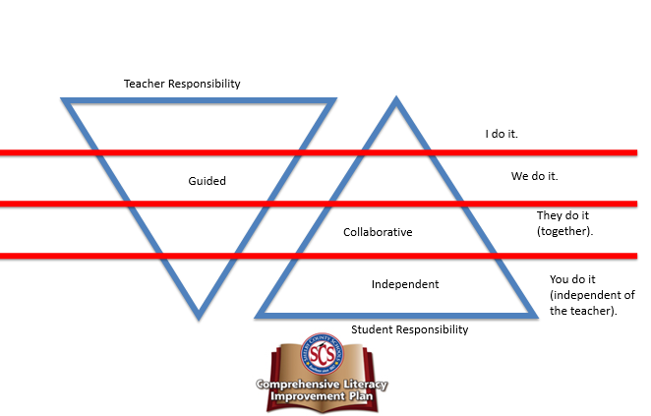

In this model, four phases occur:

* **“I do”:** The teacher provides direct instruction, establishes goals and purpose, models learning expectations
* **“We do”:** There is interactive instruction between the students and teacher.
* **“They do”:** The teacher provides groups of students a similar task. Groups of students work cooperatively and collaboratively to practice and apply the newly learned standard, skill, or strategy. The teacher moves among groups, provides support and scaffolding, and clarifies misunderstandings.
* **“You do”:** The teacher provides meaningful, differentiated tasks to individual or small groups of students that are aligned to the standard, skills, strategies. Students practice and apply new learning independently (without the direct support of the teacher). Afterwards, the teacher evaluates and provides feedback.

***Stations as a Key Strategy***

Literacy stations offer students the opportunity to engage in meaningful practice skills that have been taught during whole class instruction. It is important that students are familiar enough with the targeted skills that they are able to work independently in the stations. It is also important that all stations contain some form of age-appropriate accountability so teachers are able to monitor student performance. For example, if students are asked to use manipulatives to build words using a particular phonics pattern in a work study station, they might also be asked to write the words on paper to ensure that they have actually engaged in the task (Reutzel & Cooter, 2012).

**Literacy Stations in PreK-3 Classrooms**

Ideally, there should be 3 literacy stations in Pre-K and 4-5 literacy stations operating at any given time in a K-3 classroom. **The Phonics/Word Work station, Comprehension station, and Vocabulary station should always be available in K-3.**

For ease of management, teachers should keep the structure of each station consistent, with only the materials changing to align with the curriculum. Procedures should be taught during whole class instruction. Materials within each station should also be differentiated to meet the needs of individuals and groups of students, and the objectives for each activity should be clearly stated. For example, while most of the class is working on the long *a*/silent *e* pattern, advanced students may be sorting words into a variety of long *a* patterns in order to formulate rules for spelling, and struggling students may still be distinguishing between the long and short *a* sounds at the phonemic awareness level. Regardless of the station, the objectives for each activity should be clearly defined and stated to the students.

Textbook publishers often offer a variety of station activities, but other activities can be found at the Florida Center for Reading Research, <http://www.fcrr.org/curriculum/SCAindex.shtm>, and in many other texts that offer examples of station activities.

Note: There are various names for the station grouping configurations, such as “Literacy Work Stations” and “The Daily Five.” The names given to the stations are less significant than the type of work that is contained within each station. The work must be focused on current skills or review skills, and it must be differentiated to meet individual needs. It is also important to note that a station does not need to be a physical space, although this is highly recommended. If space is an issue, station activities can be in the form of a flip chart, folder, packet, or other type of portable device that can be carried to a desk or table. It is also crucial that station work be work that students can complete without teacher assistance.

**Examples of Station Activities for Grades K-3 Are:**

**Required**

**Phonics/Word Work (required; K-3 classes may need more than one)-**This station is particularly important for students in grades K-3. The Phonics/Word Work station can focus on individual letter sounds, phonics patterns, and/or high frequency words. Materials that can be housed in this station include magnetic and/or manipulative letters, individual white boards or chalkboards, picture sound sorts, letter tiles, sight word games, and computer games. Examples of activities for word study station can be found at the Florida Center for Reading Research, <http://www.fcrr.org/Curriculum/studentCenterActivities23.shtm>, and in Bear, Ivernizzi, Templeton, & Johnson’s (2012) *Words Their Way: Word Study for Phonics, Vocabulary, and Spelling Instruction*, 5th edition.

**Comprehension Station-** In this required station, students can practice the current comprehension skill or one that has been previously taught. This station can also be used to allow students to engage in independent reading, but it is important that students be asked to complete some type of follow-up activity—such as keeping a reading log, completing a story map or sequencing story pictures, to ensure that they have engaged in the task assigned. For younger students, this may be a listening comprehension station.

**Vocabulary Station**-Vocabulary learning is multi-faceted and consists of many different types of learning: incidental learning, explicit vocabulary instruction, and self-directed vocabulary learning. Research has shown that students must use a word multiple times for a word to become “their own,” so a vocabulary station must provide multiple ways in which a student can use words. Materials for a vocabulary station can include word sorts, dictionaries, a computer, word games, and other types of games. Teachers should also include drawing implements to allow students to create non-linguistic representations of words.

**Recommended**

**Fluency Station-**In this station, students can read word lists, phrases, or entire texts to partners who monitor and chart their progress. They can also practice for performance readings. Teachers can monitor progress by using taped readings, graphs to chart “words correct per minute,” and other means of feedback. It is recommended that students with slightly different reading levels be paired for this type of activity; it is not recommended that the most proficient students be paired with the weakest. Note: this type of activity can be combined with the Comprehension Station if it is used for the sole purpose of having students conduct timed readings with partners.

**Technology Station**-In this station, students can engage in interactive literacy activities on the computer. Depending upon the ages and abilities of the students, this station can be used for research, writing, and/or specific skills practice. **It is important to note that this is not the time for students enrolled in Tier II or Tier III interventions to engage in computer-based intervention; that needs to occur during a separate, designated intervention time.**

**Writing Station**-The Tennessee ELA Standards emphasize that students should be writing about what they are reading. A writing station can provide students with the opportunity to respond in writing by answering text-dependent questions and writing in response to their reading. Suggestions for routine writing activities are found in the SCS Curriculum Maps, but these include writing summaries and completing graphic organizers. It is important to note that, for younger students, writing often takes the form of drawing. Young writers need materials such as blank paper, markers, crayons, and picture dictionaries at the writing station to allow them to express their thoughts in developmentally appropriate ways.

**Literacy Stations in 4-5 Classrooms:**

Ideally, there should be 4-5 literacy stations operating at any given time, with Word Study, Writing, and Comprehension stations always available.

For ease of management, teachers should keep the structure of each station consistent, with only the materials changing with the curriculum. Procedures should be taught during whole class instruction. Materials within each station should also be differentiated to meet the needs of individuals and groups of students. For example, while most of the class is working on the cause and effect text structure, other students may need practice simply determining cause and effect in text. Regardless of the station, the objectives for each activity should be clearly defined and stated to the students.

Textbook publishers often offer a variety of station activities, but other activities can be found at the Florida Center for Reading Research, <http://www.fcrr.org/curriculum/SCAindex.shtm>, and in many other texts that offer examples of station activities.

Note: There are various names for the literacy station grouping configurations, such as “Literacy Work Stations” and “The Daily Five.” The names given to the stations are less significant than the type of work that is contained within each station. The work must be focused on current skills or review skills, and it must be differentiated to meet individual needs. It is also important to note that a station does not need to be a physical space. Station activities can be in the form of a flip chart, folder, packet, or other type of portable device that can be carried to a desk or table.

**Examples of Station Activities for Grades 4-5 Are:**

**Required**

**Decoding/Word Work Station-**Because many of our students struggle with foundational skills, there is merit for having such a station in grades 4-5. This station can focus on phonics patterns, syllable patterns, and/or high frequency words. In the word study station, students can build and deconstruct multisyllabic words, thus learning how the parts of words fit together to form new words. They can explore the six syllable types and examine how knowing syllable types can help with both pronunciation and meaning. Materials that can be housed in this station include magnetic and/or manipulative letters, individual white boards or chalkboards, letter tiles, and computer games. Examples of activities for word study stations can be found at the Florida Center for Reading Research, <http://www.fcrr.org/Curriculum/studentCenterActivities23.shtm>, and in Bear, Ivernizzi, Templeton, & Johnson’s (2012) *Words Their Way: Word Study for Phonics, Vocabulary, and Spelling Instruction*, 5th edition.

**Comprehension Station-**In this station, students can practice the current comprehension skill or one that has been previously taught. This station can also be used to allow students to engage in independent reading, but it is important that students be asked to complete some type of follow-up activity—such as completing a story map or sequencing story pictures, to ensure that they have engaged in the task assigned. For struggling readers, an audio version of the text can be used.

**Fluency Station-**In this station, students can read word lists, phrases, or entire texts to partners who monitor and chart their progress. They can also practice for performance readings. Teachers can monitor progress by using taped readings, graphs to chart “words correct per minute,” and other means of feedback. It is recommended that students with slightly different reading levels be paired for this type of activity; it is not recommended that the most proficient students be paired with the weakest.

**Vocabulary Station**-Vocabulary learning is multi-faceted and consists of many different types of learning: incidental learning, explicit vocabulary instruction, and self-directed vocabulary learning. Research has shown that students must use a word multiple times for a word to become “their own,” so a vocabulary station must provide multiple ways in which a student can use words. Materials for a vocabulary station can include dictionaries, a computer, word games, and other types of games. Teachers should also include drawing implements to allow students to create non-linguistic representations of words.

**Recommended**

**Technology Station**-In this station, students can engage in interactive literacy activities on the computer. Depending upon the ages and abilities of the students, this station can be used for research, writing, and/or specific skills practice. **It is important to note that this is not the time for students enrolled in Tier II or Tier III interventions to engage in computer-based intervention; that needs to occur during a separate, designated intervention time.**

**Writing Station**-The Tennessee ELA Standards emphasize that students should be writing about what they are reading. A writing station can provide students with the opportunity to respond in writing by answering text-dependent questions, gathering evidence as they read, and writing in response to their reading. Suggestions for routine writing activities are found in the SCS Curriculum Maps.

**Middle School Stations:**

Literacy stations, or centers, offer students the opportunity to practice and refine skills that have been taught during whole class instruction. It is important that students are familiar enough with the targeted skills that they are able to work independently in the centers. It is also important that all stations/centers contain some form of accountability so teachers are able to monitor student performance.

**Examples of Station/Center Activities Are:**

**Comprehension Center/Independent Reading (mandatory per week) -** Comprehension is “a complex cognitive endeavor and is affected by, at least, the reader, the text, and the context” (McKeown, Beck, and Blake, 2009, p. 218). Readers who are successful in understanding what they read use various strategies to remember what they read and to improve comprehension when understanding is hindered. At the middle school and high school level, reading comprehension is arguably the most important component of reading instruction (Boardman et al., 2008). Unfortunately, adolescent readers often lack the strategies they need to grasp the meaning of text, to repair misunderstandings, and to change these strategies based on what they are reading (Biancarosa and Snow, 2006). To improve reading comprehension, Boardman et al. (2008) and Bryant, Ugel, Thompson, and Hamff, 1999) recommended teaching comprehension strategies for students to use before, during, and/or after reading. When comprehension strategies are taught, direct and explicit instruction should be provided (Kamil et al., 2008).

**In this center**, students can practice the current comprehension skill or one that has been previously taught. This center can also be used to allow students to engage in independent reading, but it is important that students be asked to complete some type of follow-up activity—such as completing a story map or sequencing story pictures, to ensure that they have engaged in the task assigned.

**Independent Reading with Classroom Library** (or with a partner)

* Classroom Library
* Adequate number of books Balance of fiction/nonfiction
* Wide selection of multicultural literature
* Books arranged in bins or open boxes by topics (e.g. sports fiction, friendship fiction, animals nonfiction, countries and cultures nonfiction, resource books, etc.)
* Books displayed facing forward with enough space to browse
* Labeling method to return books to correct bins/boxes (e.g. books labeled with “bio” go in the “Biography” bin which is also labeled “bio”)
* Additional print materials (e. g. readers’ theater scripts, magazines, print outs of online articles etc.)

**Fluency Center (optional)** - Fluency instruction targets reading words “accurately, quickly, and with proper expression” (Malmgren and Trezek, 2009, p. 3). Most adolescent readers can read words accurately (Biancarosa and Snow, 2006); however, many students struggle with reading fluency, thereby hindering their understanding (Hasbrouck, 2006). When students learn to read fluently, they spend less time decoding and can devote their efforts toward understanding what they read (Boardman et al., 2008). In fact, increased fluency goes a long way toward increasing comprehension. Fluency is the bridge between simply reading the words on the page and actually understanding what the words mean (Malmgren and Trezek, 2009).

* **In this center**, students can read word lists, phrases, or entire texts to partners who monitor and chart their progress. They can also practice for performance readings. Teachers can monitor progress by using taped readings, graphs to chart “words correct per minute,” and other means of feedback. It is recommended that students with slightly different reading levels be paired for this type of activity; it is not recommended that the most proficient students be paired with the weakest.

**Technology Center** (optional) - In this center, students can engage in interactive literacy activities on the computer. Depending upon the ages and abilities of the students, this center can be used for research, writing, and/or specific skills practice. **It is important to note that this is not the time for students enrolled in Tier II or Tier III interventions to engage in computer-based intervention; that needs to occur during a separate, designated intervention time.**

**Word Study/Vocabulary Center (mandatory per week)** - Some adolescent readers experience difficulty simply reading words accurately; they make up the smallest subset of this population of readers (Biancarosa and Snow, 2006). For these students, instruction should include an emphasis on the building blocks of **word study**, including phonemic awareness, phonics, and preliminary fluency building (Kamil et al., 2008). The Alliance for Excellent Education (2004) estimates this percentage to be no more than 10 percent of students. Reading instruction may be more basic, with focus on letter-sound correspondence, or more advanced, with emphasis on word parts and, later, word meanings. This instruction relies on word analysis and word-recognition skills benefitting readers of any age when accompanied by grade-appropriate materials. Most adolescent readers have basic decoding skills and can read simpler text; however, as the complexity of text increases, they experience difficulties reading the words. Content-area and advanced narrative text are much more complex, in terms of both the subject matter and the words used (Schumm and Strickler, 1991). The ability to decode and comprehend multipart words is crucial for understanding the meaning of most content-area texts (Archer, Gleason, and Vachon, 2003).

**Vocabulary** instruction emphasizes word meaning. Vocabulary learning is multi-faceted and consists of many different types of learning: incidental learning, explicit vocabulary instruction, and self-directed vocabulary learning. When students understand the words they read and have strategies to find the meanings of the words, they have better understanding of what they read. Struggling readers have limited vocabularies compared to other students; without intervention, these struggling readers are likely to fall even farther behind in the content areas (Rupley and Slough, 2010). Specific-word and word-learning strategies are necessary for increasing students’ vocabularies (Armbruster et al., 2006; Boardman et al., 2008). Teachers must prepare and plan word instruction based upon the passages being read. Also, teachers must give students word-learning strategies to allow students the opportunity to build their vocabularies independently. When vocabulary instruction is provided, it should be explicit (Kamil et al., 2008). Research has shown that students must use a word multiple times for a word to become “their own,” so a vocabulary center must provide multiple ways in which a student can use words.

Materials for a **word study/vocabulary center** can include dictionaries, a computer, word games, and other types of games. Teachers should also include drawing implements to allow students to create non-linguistic representations of words. Activities may include:

* Word work (e.g. word sorts, word cognate activities)
* Multi-syllabic word activities (e.g. prefixes/suffixes, Greek and Latin word parts)
* Access to the word wall
* Activities involving discussion
* Word and sentence sorting activities
* Synonym and antonym activities
* Sequencing sentences or paragraphs
* Review activities and games

**Writing and Grammar** **Center** (to support writing instruction and for responding to reading) **(mandatory per week) -**

The Tennessee ELA Standards emphasize that students should be writing about what they are reading. A writing center can provide students with the opportunity to respond in writing by answering text-dependent questions and writing in response to their reading. Suggestions for routine writing activities and resources for the center are:

* Variety of graphic organizers related to comprehension
* Writing prompts, comprehension task cards and/or question cards at variety of levels (e. g. create an ad for.., compare and contrast two characters, describe the most important event, etc.)
* Examples of familiar writing forms (e.g. friendly letter, rhyming, Haiku, song with verse/chorus, etc.)
* Dictionaries and other word source books
* Variety of writing/drawing tools, materials (paper type) and resources

***Close Reading as a Key Strategy***

The College and Career Ready reading anchor standards clearly demand the close reading of complex text:

* Anchor Standard 1: **Read closely** to determine what the text says explicitly and to make logical inferences from it; cite specific textual evidence when writing or speaking to support conclusions drawn from the text.
* Anchor Standard 10: Read and comprehend **complex literary and informational texts** independently and proficiently.

Close reading of text is defined by The Aspen Institute in their paper *Implementing the Common Core State Standards: A Primer on “Close Reading of Text”*[16] as reading that:

involves an investigation of a short piece of text, with multiple readings done over multiple instructional lessons. Through text-based questions and discussion, students are guided to deeply analyze and appreciate various aspects of the text, such as key vocabulary and how its meaning is shaped by context; attention to form, tone, imagery and/or rhetorical devices; the significance of word choice and syntax; and the discovery of different levels of meaning as passages are read multiple times.

The teacher’s goal in the use of Close Reading is to gradually release responsibility to students—moving from an environment where the teacher models for students the strategies to one where students employ the strategies on their own when they read independently. Close Reading does more than advance reading development; it is a mechanism for teaching about logical arguments and critiquing the reasoning of others, for gleaning evidence from text and applying critical thinking skills. Close Reading is as much a way of thinking and processing text that is emphasized throughout the Common Core as it is about a way of reading a singular piece of text. Close Reading cannot be reserved for students who already are strong readers; it should be a vehicle through which all students grapple with advanced concepts and participate in engaging discussions regardless of their independent reading level (2).

According to the same paper, most close reading lessons exhibit the following attributes:

1. **Selection of a brief, high-quality, complex text.** Limiting the length of the passage allows students the opportunity to apply new skills and strategies through multiple readings of the text.
2. **Individual reading of the text.** Students unable to read the text independently might engage in a partner read or a group read in lieu of an independent attempt.
3. **Group reading aloud**. A group read aloud might be teacher- or student-led. This practice supports the engagement of all students, especially those who struggle with reading the text independently, and reinforces the primacy of the text throughout Close Reading lessons.
4. **Text-based questions and discussion that focus on discrete elements of the text.** Questions and discussion may focus on the author’s word choices and repetition, specific sentences, literary devices, academic vocabulary, or particular passages containing information that is key to the curricular objective.
5. **Discussion among students.** These discussions, either in small groups or across the whole class, will ensure that the text—as opposed to personal reflections—remains the focus as the reader explores the author’s choices.
6. **Writing about the text.** Students may be asked to reflect on the knowledge gained through Close Reading in short or long written passages (3).

Close reading is a strategy that, when applied judiciously, can help to close the achievement gap. However, it is worth noting that close reading must be employed for specific learning outcomes and should not be used every day or with every piece of text but should be situated “in the context of a comprehensive literacy framework” (4).

***Scaffolded Questions as a Key Strategy***

To effectively lead a close reading lesson or any other type of literacy lesson, teachers must engage students in text-dependent questions. The Student Achievement Partners have developed a “Guide to Creating Text-Dependent Questions” that you can see in its entirety[17] on the following two pages:

**Guide to Creating Text-Dependent Questions**

**Text-Dependent Questions: What Are They?**

The Common Core State Standards for reading strongly focus on students gathering evidence, knowledge, and insight from what they read. Indeed, nearly all of the Reading Standards in each grade *require* text-dependent analysis; accordingly, aligned curriculum materials should have a similar percentage of text-dependent questions.

As the name suggests, a text-dependent question specifically asks a question that can only be answered by referring explicitly back to the text being read. It does not rely on any particular background information extraneous to the text nor depend on students having other experiences or knowledge; instead it privileges the text itself and what students can extract from what is before them.

For example, in a close analytic reading of Lincoln’s “Gettysburg Address,” the following would not be text-dependent questions:

* *Why did the North fight the Civil War?*
* *Have you ever been to a funeral or grave site?*
* *Lincoln says that the nation is dedicated to the proposition that “all men are created equal.” Why is equality an important value to promote?*

The overarching problem with these questions is that they require no familiarity at all with Lincoln’s speech in order to answer them. Responding to these sorts of questions instead requires students to go outside the text. Such questions can be tempting to ask because they are likely to get students talking, but they take students away from considering the actual point Lincoln is making. They seek to elicit a personal or general response that relies on individual experience and opinion, and answering them will not move students closer to understanding the text of the “Gettysburg Address.”

Good text-specific questions will often linger over specific phrases and sentences to ensure careful comprehension of the text—they help students see something worthwhile that they would not have seen on a more cursory reading. Typical text-dependent questions ask students to perform one or more of the following tasks:

* Analyze paragraphs on a sentence-by-sentence basis and sentences on a word-by-word basis to determine the role played by individual paragraphs, sentences, phrases, or words
* Investigate how meaning can be altered by changing key words and why an author may have chosen one word over another
* Probe each argument in persuasive text, each idea in informational text, each key detail in literary text, and observe how these build to a whole
* Examine how shifts in the direction of an argument or explanation are achieved and the impact of those shifts
* Question why authors choose to begin and end when they do
* Note and assess patterns of writing and what they achieve
* Consider what the text leaves uncertain or unstated

**Creating Text-Dependent Questions for Close Analytic Reading of Texts**

An effective set of text-dependent questions delves systematically into a text to guide students toward extracting the key meanings or ideas found there. Text-dependent questions typically begin by exploring specific words, details, and arguments, and then move on to examine the impact of those specifics on the text as a whole. Along the way, they target academic vocabulary and specific sentence structures as critical focus points for gaining comprehension.

While there is no set process for generating a complete and coherent body of text-dependent questions for a text, the following process is a good guide that can serve to generate a core series of questions for close reading of any given text.

**Step One: Identify the Core Understandings and Key Ideas of the Text**

As in any good reverse engineering or “backwards design” process, teachers should start by reading and annotating the text, identifying the key insights they want students to understand from the text. Keeping one eye on the major points being made is crucial for fashioning an overarching set of successful questions and critical for creating an appropriate culminating assignment.

**Step Two: Start Small to Build Confidence**

The opening questions should be ones that help orient students to the text. They should also be specific enough so that students gain confidence to tackle more difficult questions later on.

**Step Three: Target Vocabulary and Text Structure**

Locate key text structures and the most powerful words in the text that are connected to the key ideas and understandings, and craft questions that draw students’ attention to these specifics so they can become aware of these connections. Vocabulary selected for focus should be academic words (“Tier Two”) that are abstract and likely to be encountered in future reading and studies.

**Step Four: Tackle Tough Sections Head-on**

Find the sections of the text that will present the greatest difficulty and craft questions that support students in mastering these sections (these could be sections with difficult syntax, particularly dense information, and tricky transitions or places that offer a variety of possible inferences).

**Step Five: Create Coherent Sequences of Text-dependent Questions**

Text-dependent questions should follow a coherent sequence to ensure that students stay focused on the text, so that they come to a gradual understanding of its meaning.

**Step Six: Identify the Standards That Are Being Addressed**

Take stock of what standards are being addressed in the series of questions and decide if any other standards are suited to being a focus for this text (forming additional questions that exercise those standards).

**Step Seven: Create the Culminating Assessment**

Develop a culminating activity around the key ideas or understandings identified earlier that (a) reflects mastery of one or more of the standards (b) involves writing, and (c) is structured to be completed by students independently.

**CLIP “Look fors” and Instructional Design by Grade Level**

**To ensure that all academic stakeholders in the District are collectively building their understanding of our vision for effective literacy instruction while also moving instructional practice to be in alignment with that vision, we have developed a few key structures and guiding documents that describe what our vision looks like in action.

These structures and documents are all centered around our vision for effective literacy instruction and are designed to empower and enable teachers to make the three CCR shifts[18] in instruction for Literacy:

1. **Regular practice with complex text and its academic language.**
2. **Reading, writing, and speaking grounded in evidence from text, both literary and informational.**
3. **Building knowledge through content-rich nonfiction.**

These tools include both observation look fors and an instructional design by grade band and are ment to support effective planning, instruction, reflection, feedback, and support.:

* PreK-3rd Grade
  + **Observation Look Fors**
  + **CLIP Instructional Design**
* 4th-5th Grade
  + **Observation Look Fors**
  + **CLIP Instructional Design**
* 6th-8th Grade
  + **Observation Look Fors**
  + **CLIP Instructional Design**
* High School
  + **Observation Look Fors**
  + **CLIP Instructional Design**

## **PreK-3 Observation Look Fors**

**Our collective goal is to ensure our students graduate ready for college and career. This will require a comprehensive, integrated approach to literacy instruction that ensures that students become college and career ready readers, writers, and communicators. To achieve this, students must receive literacy instruction aligned to each of the elements of effective literacy program seen in the figure to the right.

This planning and coaching tool is for teachers and those who support teachers in Shelby County to build their understanding and experience with College and Career Ready (CCR)[19] instruction aligned to the Comprehensive Literacy Improvement Plan. Designed as a developmental tool, it can be used for planning, reflection, collaboration, and coaching.

The three CCR shifts in instruction for ELA/Literacy provide the framing for this tool:

(1) Regular practice with complex text and its academic language.

1. Reading, writing, and speaking grounded in evidence from text, both literary and informational.
2. Building knowledge through content-rich nonfiction.

The Core Actions and indicators should be evidenced in planning and observable in instruction. For each lesson, evidence might include a lesson plan, exercises, tasks and assessments, teacher instruction, student discussion and behavior, and student work. Although many indicators will be observable during the course of a lesson, there may be times when a lesson is appropriately focused on a smaller set of objectives or only a portion of a lesson is observed, leaving some indicators blank.

|  |  |
| --- | --- |
| **Indicator** | **Evidence Observed** |
| 1. The teacher has a dedicated literacy block that lasts for the required number of minutes (50 minutes for PreK, 120 minutes for Kindergarten-3rd Grade) during which students access core/Tier 1 content. |  |
| 1. The teacher maximizes time[20] by employing the PreK-3 CLIP instructional design, including the whole group-small group – whole group structure and the required number of minutes for each component of the instructional design. |
| 1. The teacher gradually releases responsibility throughout the lesson, modeling new skills before giving students the opportunity to practice together and independently. |
| 1. The teacher provides the conditions for all students to focus on the text, and students clearly know the routines and procedures in the classroom. |

|  |  |
| --- | --- |
| **Indicator** | **Evidence Observed** |
| 1. A majority of the lesson is spent reading, speaking, or writing about text(s). |  |
| 1. The text(s) are at or above the complexity level expected for the grade and time in the school year. |
| 1. The text(s) exhibit exceptional craft and thought and/or provide useful information. |
| 1. Texts are selected strategically to develop a coherent body of knowledge. |

|  |  |
| --- | --- |
| **Indicator** | **Evidence Observed** |
| 1. The foundational skills being taught are aligned to the standards for this grade. |  |
| 1. Instruction and materials address foundational skills by attending to phonological awareness, concepts of print, letter recognition, phonetic patterns, and word structure. |
| 1. Instruction and materials provide sufficient opportunities for all students to practice reading and writing newly acquired foundational skills. |
| 1. Instruction and materials connect acquisition of foundational skills to making meaning from reading. |
| 1. Instruction and materials provide opportunities for students to demonstrate understanding of the skills being taught through frequent monitoring of student progress. |
| 1. The teacher effectively uses small group instruction/guided reading time to differentiate for students to ensure that all students master foundational skills. |
| 1. The teacher effectively uses small group instruction/stations to differentiate for students to ensure that all students master foundational skills. |

|  |  |
| --- | --- |
| **Indicator** | **Evidence Observed** |
| 1. Questions and tasks address the text by attending to its particular structure, concepts, ideas, events and details. |  |
| 1. Questions and tasks require students to use evidence from text to demonstrate understanding and to support their ideas about the text. These ideas are expressed through a variety of means. |
| 1. Questions and tasks attend to the words, phrases, and sentences within the text. |
| 1. Questions are sequenced to build knowledge by guiding students to delve deeper into text and graphics. |
| 1. The teacher sets clear text-based objectives for literacy throughout the lesson. |
| 1. The teacher implements specific literacy stations, including the required PreK-3 literacy stations (phonics/word work, comprehension, vocabulary.) |

|  |  |
| --- | --- |
| **Indicator** | **Notes** |
| 1. The teacher keeps all students persevering with challenging tasks. |  |
| 1. The teacher encourages reasoning and problem solving by posing challenging questions and tasks that offer opportunity for productive struggle. |
| 1. The teacher guides students to read with purpose and understanding by making frequent connections between acquisition of foundational skills and making meaning from reading. |
| 1. The teacher demonstrates awareness and appropriate action regarding the variations present in student progress towards reading independently. |
| 1. The teacher focuses on explicitly and systematically strengthening students’ foundational reading skills. |
| 1. The teacher provides differentiated support for students throughout the course of the lesson, particularly in small-group instruction. |
| 1. The teacher allows all students to synthesize their learning in the closing of the lesson, assessing students’ understanding of the text and mastery of specific skills during the lesson closing. |

## **PreK-3 Instructional Design**

**We have the opportunity to build a strong foundation for reading in our PreK-3 students. To ensure that time for literacy instruction is used well, we have developed the PreK-3 CLIP instructional design. It clearly lays out how to leverage time and effective lesson design in the literacy block.

The purpose of this instructional design is to ensure that **all** PreK-3 students receive the high-quality instruction to meet our vision for effective literacy instruction. This instructional design is *not* intended to replace teachers’ professional judgment about how to spend time with their particular students , but is intended to ensure that all teachers can clearly define how a strong literacy block is paced and the components of a strong literacy block.

All PreK teachers should ensure that their literacy (reading) block is 50 minutes long; all kindergarten to third grade teachers should ensure that their literacy (reading and writing) block is 120 minutes long. Teachers should use **the gradual release of responsibility model** (“I do, we do, they do, you do”) **to ensure that students have the opportunity to read, write, and think about complex texts while also receiving explicit, systematic foundational skills instruction done in service of building students’ reading comprehension,** as described in our vision for effective literacy instruction and the PreK-3 Observation Look Fors.

PreK-3 students should generally have the following experiences:

|  |  |  |
| --- | --- | --- |
|  | Reading Appropriately Complex Texts[21] | Writing About Texts (and ELA)[22] |
| Tier 1, Grade-Level Instruction for All Students | | |
| Whole Group | Collaborative reading of texts sequenced to build student knowledge; explicit instruction on reading foundational skills | Modeled and shared writing; modeling writing skills |
| Small Group | Homogeneous and heterogeneous groupings; practice and apply skills to read appropriately complex texts | Independent and group writing; practice and apply skills |
| Whole Group | Closure and assessment | Closure, assessment, sharing of student work |

**4th-5th Grade Observation Look Fors**

**Our collective goal is to ensure our students graduate ready for college and career. This will require a comprehensive, integrated approach to literacy instruction that ensures that students become college and career ready readers, writers, and communicators. To achieve this, students must receive literacy instruction aligned to each of the elements of effective literacy program seen in the figure to the right.

This planning and coaching tool is for teachers and those who support teachers in Shelby County to build their understanding and experience with College and Career Ready (CCR)[23] instruction aligned to the Comprehensive Literacy Improvement Plan. Designed as a developmental tool, it can be used for planning, reflection, collaboration, and coaching.

The three CCR shifts in instruction for ELA/Literacy provide the framing for this tool:

(1) Regular practice with complex text and its academic language.

1. Reading, writing, and speaking grounded in evidence from text, both literary and informational.
2. Building knowledge through content-rich nonfiction.

The Core Actions and indicators should be evidenced in planning and observable in instruction. For each lesson, evidence might include a lesson plan, exercises, tasks and assessments, teacher instruction, student discussion and behavior, and student work. Although many indicators will be observable during the course of a lesson, there may be times when a lesson is appropriately focused on a smaller set of objectives or only a portion of a lesson is observed, leaving some indicators blank.

|  |  |
| --- | --- |
| **Indicator** | **Evidence Observed** |
| 1. The teacher has a dedicated literacy block that lasts for the required number of minutes (120 minutes for 4th-5th grade) during which students access core/Tier 1 content. |  |
| 1. The teacher maximizes time[24] by employing the 4th-5th grade CLIP instructional design (including the whole group-small group – whole group structure and the required number of minutes for each component of the instructional design). |
| 1. The teacher gradually releases responsibility throughout the lesson, modeling new skills before giving students the opportunity to practice together and independently. |
| 1. The teacher provides the conditions for all students to focus on the text, and students clearly know the routines and procedures in the classroom. |

|  |  |
| --- | --- |
| **Indicator** | **Evidence Observed** |
| 1. A majority of the lesson is spent reading, speaking, or writing about text(s). |  |
| 1. The text(s) are at or above the complexity level expected for the grade and time in the school year. |
| 1. The text(s) exhibit exceptional craft and thought and/or provide useful information. |
| 1. Texts are selected strategically to develop a coherent body of knowledge. |

|  |  |
| --- | --- |
| **Indicator** | **Evidence Observed** |
| 1. The foundational skills being taught are aligned to the standards for this grade. |  |
| 1. Instruction and materials address foundational skills by attending to phonics, word recognition, and fluency. |
| 1. Instruction and materials provide sufficient opportunities for all students to practice reading and writing newly acquired foundational skills. |
| 1. Instruction and materials connect acquisition of foundational skills to making meaning from reading. |
| 1. Instruction and materials provide opportunities for students to demonstrate understanding of the skills being taught through frequent monitoring of student progress. |
| 1. The teacher effectively uses small group instruction/guided reading time to differentiate for students to ensure that all students master foundational skills. |
| 1. The teacher effectively uses small group instruction/stations to differentiate for students to ensure that all students master foundational skills. |

|  |  |
| --- | --- |
| **Indicator** | **Evidence Observed** |
| 1. Questions and tasks address the text by attending to its particular structure, concepts, ideas, events and details. |  |
| 1. Questions and tasks require students to use evidence from text to demonstrate understanding and to support their ideas about the text. These ideas are expressed through a variety of means. |
| 1. Questions and tasks attend to the words, phrases, and sentences within the text. |
| 1. Questions are sequenced to build knowledge by guiding students to delve deeper into text and graphics. |
| 1. The teacher sets clear text-based objectives for literacy throughout the lesson. |
| 1. The teacher implements specific literacy stations, including the required 4th and 5th grade literacy stations (decoding/word work, comprehension, vocabulary.). |

|  |  |
| --- | --- |
| **Indicator** | **Notes** |
| 1. The teacher keeps all students persevering with challenging tasks. |  |
| 1. The teacher expects evidence and precision from students and probes students’ answers accordingly. |
| 1. The teacher encourages reasoning and problem solving by posing challenging questions and tasks that offer opportunity for productive struggle. |
| 1. The teacher demonstrates awareness and appropriate action regarding the variations present in student progress towards reading independently. |
| 1. When appropriate, the teacher explicitly attends to strengthening students’ language and foundational skills. |
| 1. The teacher provides differentiated support for students throughout the course of the lesson, particularly in small-group instruction. |
| 1. The teacher allows all students to synthesize their learning in the closing of the lesson, assessing students’ understanding of the text and mastery of specific skills during the lesson closing. |

****4th-5th Grade Instructional Design**  
We have the opportunity to ensure that our fourth and fifth grade students have built their capacity as readers to the point that they are ready to enter middle school. To ensure that time for literacy instruction is used well, we have developed the 4th and 5th grade CLIP instructional design. It clearly lays out how to leverage time and effective lesson design in the literacy block.

The purpose of this instructional design is to ensure that **all** 4th and 5th grade students receive the high-quality instruction to meet our vision for effctive literacy instruction. This instructional design is *not* intended to replace teachers’ professional judgment about how to spend time with their particular students but is intended to ensure that all teachers can clearly define how a strong literacy block is paced and the components of a strong literacy block.

All fourth and fifth grade teachers should ensure that their literacy (reading and writing) block is 120 minutes long. Teachers should use **the gradual release of responsibility model** (“I do, we do, they do, you do”) **to ensure that students have the opportunity to read, write, discuss and think about complex texts,** as described in our vision for effective literacy instruction and in the 4th-5th Grade Observation Look Fors.

4th and 5th grade students should generally have the following experiences:

|  |  |  |
| --- | --- | --- |
|  | Reading Appropriately Complex Texts[25] | Writing Aboout Texts (and ELA)[26] |
| Tier 1, Grade-Level Instruction for All Students | | |
| Whole Group | Collaborative reading of texts sequenced to build student knowledge | Modeled and shared writing; modeling writing skills |
| Small Group | Homogeneous and heterogeneous groupings; practice and apply skills to read appropriately complex texts | Independent and group writing; practice and apply skills |
| Whole Group | Closure and assessment | Closure, assessment, sharing of student work |

****6th-8th Grade Observation Look Fors**

Our collective goal is to ensure our students graduate ready for college and career. This will require a comprehensive, integrated approach to literacy instruction that ensures that students become college and career ready readers, writers, and communicators. To achieve this, students must receive literacy instruction aligned to each of the elements of effective literacy program seen in the figure to the right.

This planning and coaching tool is for teachers and those who support teachers in Shelby County to build their understanding and experience with College and Career Ready (CCR)[27] instruction aligned to the Comprehensive Literacy Improvement Plan. Designed as a developmental tool, it can be used for planning, reflection, collaboration, and coaching.

The three CCR shifts in instruction for ELA/Literacy provide the framing for this tool:

(1) Regular practice with complex text and its academic language.

1. Reading, writing, and speaking grounded in evidence from text, both literary and informational.
2. Building knowledge through content-rich nonfiction.

The Core Actions and indicators should be evidenced in planning and observable in instruction. For each lesson, evidence might include a lesson plan, exercises, tasks and assessments, teacher instruction, student discussion and behavior, and student work. Although many indicators will be observable during the course of a lesson, there may be times when a lesson is appropriately focused on a smaller set of objectives or only a portion of a lesson is observed, leaving some indicators blank.

|  |  |
| --- | --- |
| **Indicator** | **Evidence Observed** |
| 1. The teacher has a dedicated literacy block that lasts for the duration of the class period during which students access core/Tier 1 content. |  |
| 1. The teacher maximizes time[28] by employing the 6th-8th grade CLIP instructional design (including the whole group-small group – whole groupclosure structure). |
| 1. The teacher gradually releases responsibility throughout the lesson, modeling new skills before giving students the opportunity to practice together and independently. |
| 1. The teacher provides the conditions for all students to focus on the text, and students clearly know the routines and procedures in the classroom. |

|  |  |
| --- | --- |
| **Indicator** | **Evidence Observed** |
| 1. A majority of the lesson is spent reading, speaking, or writing about text(s). |  |
| 1. The text(s) are at or above the complexity level expected for the grade and time in the school year. |
| 1. The text(s) exhibit exceptional craft and thought and/or provide useful information. |
| 1. Texts are selected strategically to develop a coherent body of knowledge. |  |

|  |  |
| --- | --- |
| **Indicator** | **Evidence Observed** |
| 1. Questions and tasks address the text by attending to its particular structure, concepts, ideas, events and details. |  |
| 1. Questions and tasks require students to use evidence from text to demonstrate understanding and to support their ideas about the text. These ideas are expressed through a variety of means. |
| 1. Questions and tasks attend to the words, phrases, and sentences within the text. |
| 1. Questions are sequenced to build knowledge by guiding students to delve deeper into text and graphics. |
| 1. The teacher sets clear text-based objectives for literacy throughout the lesson. |
| 1. The teacher effectively uses small group instruction/stations to differentiate for students to ensure that all students can access Tier 1 content. |
| 1. The teacher implements specific literacy stations, including the required 6th, 7th, and 8th grade literacy stations **(**comprehension/independent reading, word study/ vocabulary, fluency, and writing/grammar) on a weekly basis based on student and group needs. |

|  |  |
| --- | --- |
| **Indicator** | **Notes** |
| 1. The teacher keeps all students persevering with challenging tasks. |  |
| 1. The teacher expects evidence and precision from students and probes students’ answers accordingly. |
| 1. The teacher encourages reasoning and problem solving by posing challenging questions and tasks that offer opportunity for productive struggle. |
| 1. The teacher demonstrates awareness and appropriate action regarding the variations present in student progress towards reading independently. |
| 1. When appropriate, the teacher explicitly attends to strengthening students’ language and foundational skills. |
| 1. The teacher provides differentiated support for students throughout the course of the lesson, particularly in small-group instruction, to ensure that all students can access grade-level texts. |
| 1. The teacher allows all students to synthesize their learning in the closing of the lesson, assessing students’ understanding of the text and mastery of specific skills during the lesson closing. |

****6th-8th Grade Instructional Design**We have the opportunity to ensure that our middle school students have built their capacity as readers to the point that they are ready to enter high school. To ensure that time for literacy instruction is used well, we have developed the 6th, 7th, and 8th grade CLIP instructional design. It clearly lays out how to leverage time and effective lesson design in the literacy block.

The purpose of this instructional design is to ensure that **all** middle school students receive the high-quality instruction to meet our vision for effective literacy instruction. This instructional design is *not* intended to replace teachers’ professional judgment about how to spend time with their particular students but is intended to ensure that all teachers can clearly define the components and pacing of a strong literacy block/English class period.

Teachers should use **the gradual release of responsibility model** (“I do, we do, they do, you do”) **to ensure that students have the opportunity to read, write, discuss and think about complex texts,** as described in our vision for effective literacy instruction and in the 6th-8th Grade Observation Look Fors.

Middle school students should generally have the following experiences:

|  |  |  |
| --- | --- | --- |
|  | Reading Appropriately Complex Texts | Writing About Texts (and ELA) |
| Tier 1, Grade-Level Instruction for All Students | | |
| Whole Group  (approximately 30 minutes) | Collaborative reading of texts sequenced to build student knowledge | Modeled and shared writing; modeling writing skills |
| Small Group  (approximately 20 minutes) | * Homogeneous and heterogeneous groupings; practice and apply skills to read appropriately complex texts | Independent and group writing; practice and apply skills |
| Whole Group (5 minutes) | Closure and assessment | Closure, assessment, sharing of student work |

**High School Observation Look Fors**

**Our collective goal is to ensure our students graduate ready for college and career. This will require a comprehensive, integrated approach to literacy instruction that ensures that students become college and career ready readers, writers, and communicators. To achieve this, students must receive literacy instruction aligned to each of the elements of effective literacy program seen in the figure to the right.

This planning and coaching tool is for teachers and those who support teachers in Shelby County to build their understanding and experience with College and Career Ready (CCR)[29] instruction aligned to the Comprehensive Literacy Improvement Plan. Designed as a developmental tool, it can be used for planning, reflection, collaboration, and coaching.

The three CCR shifts in instruction for ELA/Literacy provide the framing for this tool:

(1) Regular practice with complex text and its academic language.

1. Reading, writing, and speaking grounded in evidence from text, both literary and informational.
2. Building knowledge through content-rich nonfiction.

The Core Actions and indicators should be evidenced in planning and observable in instruction. For each lesson, evidence might include a lesson plan, exercises, tasks and assessments, teacher instruction, student discussion and behavior, and student work. Although many indicators will be observable during the course of a lesson, there may be times when a lesson is appropriately focused on a smaller set of objectives or only a portion of a lesson is observed, leaving some indicators blank.

|  |  |
| --- | --- |
| **Indicator** | **Evidence Observed** |
| 1. Tier I content is taught in the standard English I, II, III, and IV bell schedule. |  |
| 1. The teacher maximizes time[30] by employing the High School CLIP instructional design (including the whole group-small group – whole groupclosure structure). |
| 1. The teacher gradually releases responsibility throughout the lesson, modeling new skills before giving students the opportunity to practice together and independently. |
| 1. The teacher provides the conditions for all students to focus on the text, and students clearly know the routines and procedures in the classroom. |

|  |  |
| --- | --- |
| **Indicator** | **Evidence Observed** |
| 1. A majority of the lesson is spent reading, speaking, or writing about text(s). |  |
| 1. The text(s) are at or above the complexity level expected for the grade and time in the school year. |
| 1. The text(s) exhibit exceptional craft and thought and/or provide useful information. |
| 1. Texts are selected strategically to develop a coherent body of knowledge. |

|  |  |
| --- | --- |
| **Indicator** | **Evidence Observed** |
| 1. Questions and tasks address the text by attending to its particular structure, concepts, ideas, events and details. |  |
| 1. Questions and tasks require students to use evidence from text to demonstrate understanding and to support their ideas about the text. These ideas are expressed through a variety of means. |
| 1. Questions and tasks attend to the words, phrases, and sentences within the text. |
| 1. Questions are sequenced to build knowledge by guiding students to delve deeper into text and graphics. |
| 1. The teacher sets clear text-based objectives for literacy throughout the lesson. |
| 1. The teacher effectively uses small group instruction to differentiate for students to ensure that all students can access Tier 1 content. |

|  |  |
| --- | --- |
| **Indicator** | **Notes** |
| 1. The teacher keeps all students persevering with challenging tasks. |  |
| 1. The teacher expects evidence and precision from students and probes students’ answers accordingly. |
| 1. The teacher encourages reasoning and problem solving by posing challenging questions and tasks that offer opportunity for productive struggle. |
| 1. The teacher demonstrates awareness and appropriate action regarding the variations present in student progress towards reading independently. |
| 1. When appropriate, the teacher explicitly attends to strengthening students’ language and foundational skills. |
| 1. The teacher provides differentiated support for students throughout the course of the lesson, particularly in small-group instruction, to ensure that all students can access grade-level texts. |
| 1. The teacher allows all students to synthesize their learning in the closing of the lesson, assessing students’ understanding of the text and mastery of specific skills during the lesson closing. |

****High School Instructional Design**  
We have the opportunity to ensure that our high school students have built their capacity as readers to the point that they are ready for college and career . To ensure that time for literacy instruction is used well, we have developed the high school CLIP instructional design. It clearly lays out how to leverage time and effective lesson design in the literacy block.

The purpose of this instructional design is to ensure that **all** high school students receive the high-quality instruction to meet our vision for effective literacy instruction. This instructional design is *not* intended to replace teachers’ professional judgment about how to spend time with their particular students but is intended to ensure that all teachers can clearly define how a strong literacy block is paced and the components of a strong literacy block.

All high school teachers should use **the gradual release of responsibility model** (“I do, we do, they do, you do”) **to ensure that students have the opportunity to read, write, discuss and think about complex texts,** as described in our vision for effective literacy instruction and in the High School Observation Look Fors.

High school students should generally have the following experiences:

|  |  |  |  |
| --- | --- | --- | --- |
|  | Reading | Writing | ELA |
| Tier 1, Grade-Level Instruction for All Students | | | |
|  | **Complex Texts** | **Writing about Texts** | **Taught in the context of writing** |
| Whole Group | Reading grade-level texts, teach and model grade level standards and skills (“I do” when teacher models and “We do” when teacher and students work collaboratively.) | Writing in response to grade-level texts, teach and model grade level standards and skills (“I do” when teacher models and “We do” when teacher and students work collaboratively.) | CCR-aligned language skills learned in the context of writing in response to grade-level texts, teach and model grade level standards and skills (“I do” and “We do”). |
| Small Group | Teacher led and flexible groups | Teacher led and flexible groups | Teacher led and flexible groups |
| Whole Group | Closure – summarize what you have learned. | Closure – summarize what you have learned. | Closure – summarize what you have learned. |

***Using the SCS Curriculum Maps***

Though many people use the terms “adopted text” and “curriculum” interchangeably, they have different meanings. Driven by the standrds, curricula define the scope of content to be taught, as well as recommendations for sequencing and pacing. Curriculum guides further this work by calrifying resources, including, but not limited to textbooks, programs, and additional resources to help support these carefully planned instructional progressions. Because effectiev instruction, requires more than simply “covering” the standards one-by-one or marching students through the a textbook, page by page, and planning effective, standards-aligned instructional units and identifying high-quality instructional resources takes time, SCS curriculum frameworks are designed as resources to make planning easier for teachers. The guidea identify the scope, sequence, pacing, and resources so that teachers and coaches can better focus on the how of instruction—how to support learning to the standards.

The SCS-adopted, curricular materials require teachers to carefully plan to ensure that students are always being exposed to and supported in mastering rigorous content during core instruction. Each grade level’s set of adopted materials has some strengths that will enable students to meet the demands of the standards if curricular materials are used as written; however, each grade level’s adopted materials also contains some weaknesses that will require supplementing to ensure that students are exposed to CCR content. The Instructional Materials Evalution Toolkit[31] is a tool that enables teachers and other stakeholders to evaluate curricular resources to determine what areas of strength and weakness exist in a given set of resources.  
  
As outlined in the SCS Theory of Action for Improving Literacy Teaching and Learning, the District holds the responsibility for selecting primary curricular materials that reflect the demands of the standards and creating high-quality supplements and curriculum guides that illuminate the strengths, address the gaps of adopted materials, and help staff to understand and meet expectations for scope, sequencing, and pacing. School leaders then implement the adopted curriculuar materials by developing teacher’s judgment in making vision-aligned planning and execution decisions, and teachers exercise that judgment to effectively leverage curricular resources to ensure that students achievement imrproves.

The District has done significant work to ensure that the SCS curriculum maps will enable teachers to meet the demands of the CCR standards while also ensuring that teachers are able to identify the strengths and areas for growth of the SCS adopted curricular materials. In alignment with the prioritized areas of focus for the first nine weeks of the school year, the C&I team has focused on ensuring that **the SCS curriculum maps identify only high-quality, grade-level appropriate texts that teachers should be using in their classrooms** (eliminating some texts in given textbooks because they simply do not meet the text complexity demands of the standards, outlined above). Each curriculum map contains high-quality texts that meet the demands of the standards along with paired standards that outline the skills and strategies that students would need to apply in order to truly make sense of the given text(s).

Our goal in providing these resources is to ensure that teachers have support in identifying the resources that they have available to meet the demands of the standards. To ensure that the C&I team has the time and capacity to carefully audit the provided curricular resources and supplement as necessary, curriculum maps will be released one quarter at a time.

**Understanding of how the CLIP and the TEM evaluation system enable us to ensure that our students achieve the TNCore standards**

In 2014, Shelby County Schools (SCS) formally adopted three ambitious 2025 goals:

* 80% of our students will graduate from high school, college and career ready;
* 90% graduation of students will graduate on time; and
* 100% of our students who graduate college and career ready will enroll in a post-secondary opportunity.

Referred to as Shelby County’s “80/90/100” goals, these goals, along with the districtwide Strategic Plan, established a more aggressive approach to improving literacy teaching across all grade levels and schools. To better illustrate this charge, the District drafted the *Comprehensive Literacy Improvement Plan* (CLIP), which was designed to articulate a common vision and purpose for literacy instruction in Shelby County Schools. This plan articulated the:

* District’s expectations for what students should know and be able to do college and career ready literacy classrooms.
* Characteristics or features of College and Career Ready Standards aligned, effective literacy instruction and the evidence and outcomes that observers will look for during both formal and informal observations, including evidence that teachers are creating the enabling conditions and using the instructional design model of the CLIP, as well as the three core CLIP actions:
  + **Core Action 1:** Focus each lesson on a high quality text or multiple texts.
  + **Core Action 2:** Employ questions and tasks that are text dependent and text specific.
  + **Core Action 3:** Provide all students with opportunities to engage in the work of the lesson.
* Professional development training and supports that will be designed and executed to help guide departments, schools, leaders and teachers through the implementation of CLIP.
* Instructional tools and resources [texts, curriculum maps, pacing guides, lesson planning templates, etc.] that schools and teachers can use in their implementation of College and Career Ready standards and CLIP.
* Systems and tools that schools can use to assess student learning and monitor progress and implementation.

Along with these resources, the District recognized the need to show how CLIP aligned to some of our existing structures, most notably, the Teacher Effectiveness Measure Framework or TEM Rubric. The following document outlines how SCS’s TEM Rubric and the CLIP work together in service of improving teacher performance and student outcomes.

While there are no guaranteed steps or lesson plans for either always achieving a TEM 5 when observed or consistently achieving the highest levels of learning growth for all students, there are some goals, key design principles, and core actions that hold significant promise for advancing teacher performance and achieving our Destination 2025 goals.

|  |  |  |  |
| --- | --- | --- | --- |
| TEACH 1: Objective Driven Lessons  Engage students in objective driven lessons on content standards. | | | |
| LEVEL 3  Evidence-Based Reflection Questions[32] | TEM Teacher Behaviors | TEM Student Behaviors[33] | CLIP Look Fors[34] |
| * Does the teacher communicate the lesson objective? If so, what does he/she say? * Does the teacher communicate the lesson objective in relationship to standards? If so, what does he/she say? * How does the teacher explain or model what mastery of the objective will look like? * Does the teacher provide multiple opportunities for engagement in the lesson objectives? If so, what do these opportunities look like? * Can students explain or demonstrate what they are learning beyond simply repeating the stated or posted objective? What %? * Can students explain the importance of what they are learning? What %? * Can students describe how their learning will be assessed? What %? | * Teacher communicates objective in relationship to the standard. * Teacher uses developmentally appropriate language. * Teacher explains and models mastery. * Teacher provides multiple opportunities for engagement in the lesson objective and connects activities to prior knowledge. | * Students explain or demonstrate what they are learning beyond simply repeating the stated or posted objectives. * Students can explain the importance of their learning. * Students can describe how their learning will be assessed. | * (For PreK-5 classrooms) The foundational skills being taught are aligned to the standards for this grade. * (For PreK-5 classrooms) Instruction and materials address foundational skills by attending to phonological awareness, concepts of print, letter recognition, phonetic patterns, and word structure. * The teacher sets clear text-based objectives for literacy throughout the lesson. * (PreK-5 Classrooms) The teacher guides students to read with purpose and understanding by making frequent connections between acquisition of foundational skills and making meaning from reading. * (PreK-5 Classrooms) The teacher focuses on explicitly and systematically strengthening students’ foundational reading skills. |

|  |  |  |  |
| --- | --- | --- | --- |
| TEACH 2: Explain ContentExplain content clearly and accurately. | | | |
| LEVEL 3  Evidence-Based Reflection Questions | TEM Teacher Behaviors | TEM Student Behaviors | CLIP Look Fors |
| * How does the teacher explain or demonstrate content? What does student understanding look like? * Does the teacher utilize multiple perspectives/approaches to solve problems or interpret text/content? If so, how? * Does the teacher make relevant connections with other content areas, students’ experiences and interest, or current events? If so, how? * Does the teacher use explanations that are developmentally appropriate? Does the teacher include academic language that is clear and concise? * Does the teacher make adjustments when appropriate? Does the teacher have alternative ways of explaining content? | * Teacher explains content, clearly and accurately. * Teacher uses multiple perspective/approaches. * Teacher makes relevant connections with other content areas, student experiences and interests. * Teacher explains content using developmentally appropriate, academic language. * Teacher makes adjustments and provides alternative ways to explain content. * Teacher models performance expectations * Teacher provides logical sequencing of all essential information. | * Students understand the content. * Students ask clarifying questions. | * The teacher gradually releases responsibility throughout the lesson, modeling new skills before giving students the opportunity to practice together and independently. * Questions and tasks attend to academic language (i.e. vocabulary and syntax) in the text. |

|  |  |  |  |
| --- | --- | --- | --- |
| TEACH 3: Appropriately Challenging Work  Engage students at all learning levels in appropriately challenging work. | | | |
| LEVEL 3  Evidence-Based Reflection Questions | TEM Teacher Behaviors | TEM Student Behaviors | CLIP Look Fors |
| * Are students engaged in appropriately challenging work? Are students being reached? What %? How do you know? * Are all students being challenged? What %? How do you know? * Are student learning levels/styles being met? What %? How do you know? * Has the teacher included complex texts, tasks and activities to support students’ mastery of objectives? If so, what do these materials look like? What makes them complex? * Do the lesson materials and activities sustain the attention of students and their learning levels/styles? | * Teacher engages students in appropriately challenging work. * Teacher challenges students. * Teacher meet students’ learning levels/styles. * Teacher includes appropriately complex text, task, and activities to support student mastery of objective. * Teacher incorporates activities and materials that sustain student attention | * Students are reached. * Students are challenged. * Students’ learning levels and styles are met. * Students master objectives. * Students’ attention is sustained throughout lesson. | * The text(s) are at or above the complexity level expected for the grade and time in the school year. * The text(s) exhibit exceptional craft and thought and/or provide useful information. * (PreK-5 classrooms) The teacher effectively uses small group instruction/guided reading time to differentiate for students to ensure that all students master foundational skills. * (PreK-5 classrooms) The teacher effectively uses small group instruction/stations to differentiate for students to ensure that all students master foundational skills. * The teacher keeps all students persevering with challenging tasks. * (PreK-5) The teacher demonstrates awareness and appropriate action regarding the variations present in student progress towards reading independently. * The teacher provides differentiated support for students throughout the course of the lesson, particularly in small-group instruction. |

|  |  |  |  |
| --- | --- | --- | --- |
| TEACH 4: Content Engagement  Provide students multiple ways to engage with content. | | | |
| LEVEL 3  Evidence-Based Reflection Questions | TEM Teacher Behaviors | TEM Student Behaviors | CLIP Look Fors |
| * Are the engagement strategies purposeful and do they align to the lesson objectives? * Does the lesson contain a balance of teacher-directed instruction and student-centered learning? * Do the strategies enable students to meet the lesson objectives with appropriate scaffolding and differentiation? * Do students have the opportunity to practice, apply, and demonstrate content mastery through discussion or writing? * Does the teacher model and implement appropriate strategies that teach or reinforce one of the 9 types of problem-solving? | * Teacher incorporates engagement strategies aligned to objective. * Teacher balances between teacher and student centered lesson. * Teacher uses strategies that enab`le students to meet objective, using scaffolding and differentiation when appropriate. * Teacher allows students to practice, apply, and demonstrate mastery through discussion/writing. * Teacher models at least one type of problem solving strategy. | * Students participate in a student-centered lesson. * Students meet lesson objective. * Students practice, apply and demonstrate content mastery. | * (For PreK-5 classrooms) Instruction and materials provide sufficient opportunities for all students to practice reading and writing newly acquired foundational skills. * The teacher implements specific literacy stations, including the required grade-specific literacy stations. |

|  |  |  |  |
| --- | --- | --- | --- |
| TEACH 5: Higher Level Thinking Skills  Use strategies that develop higher-level thinking skills. | | | |
| LEVEL 3  Evidence-Based Reflection Questions | TEM Teacher Behaviors | TEM Student Behaviors | CLIP Look Fors |
| * Do students develop higher-level thinking skills by engaging in some of the lesson strategies or activities? * Does the teacher model his thought process for generating and asking questions, so that students generate their own? * Does the teacher provide helpful suggestions or redirect with questions? * Does the teacher ask questions and include tasks that move students beyond their initial thinking? * Does the teacher model and implement appropriate strategies that teach or reinforce one of the 9 types of problem-solving? * Does the teacher engage students in tasks that address one of the 4 types of thinking outlined in the TEM Rubric? | * Teacher develops higher-level thinking skills. * Teacher models thought process for generating and asking questions. * Teacher provides helpful suggestions and/or redirects with questions, rather than simply providing the answer. * Teacher asks questions and includes tasks that move students beyond their initial think. * Teacher requires students to cite relevant evidence. * Teacher thoroughly teaches and engages students in task, activities or strategies that address one type of thinking relevant to the learning objective and content. | * Students engage in activities, tasks, and/or discussions that build on solid foundation of knowledge. * Students generate their own questions. * Students move beyond their initial thinking. * Students cite relevant evidence. * Students engage in tasks, activities, and strategies that address one type of thinking relevant to learning objectives and content. | * (PreK-5 classrooms) Instruction and materials connect acquisition of foundational skills to making meaning from reading. * Questions and tasks require students to cite evidence from the texts to support analysis, inferences, and claims. * The teacher encourages reasoning and problem solving by posing challenging questions and tasks that offer opportunity for productive struggle. |

|  |  |  |  |
| --- | --- | --- | --- |
| TEACH 6: Check for Understanding  Check for understanding and respond appropriately during the lesson. | | | |
| LEVEL 3  Evidence-Based Reflection Questions | TEM Teacher Behaviors | TEM Student Behaviors | CLIP Look Fors |
| * Does the teacher check for understanding of content by addressing misunderstandings with another approach/strategy? * Does the teacher circulate during instructional activities to support engagement and provide relevant feedback? * Does the teacher formatively assess students’ work in order to adjust instruction in real time? * Does the teacher use scaffolding techniques, so that students construct their own understanding? * Does the teacher address/correct student misunderstandings? * Does the teacher utilize a variety of methods to check for understanding? | * Teacher checks for understanding. * Teacher addresses misunderstandings with another approach/strategy. * Teacher circulates during instructional activities to support engagement and provide relevant feedback. * Teacher formatively assesses student work in order to adjust instruction. * Teacher uses scaffolding techniques. * Teacher addresses/corrects student misunderstandings. * Teacher utilizes a variety of methods to check for understanding. | * Student misunderstandings are addressed. * Students construct understanding after receiving scaffolding. * Students remain engaged in the lesson while the misunderstandings of students who do not understand are addressed. | * (PreK-5 Classrooms) Instruction and materials provide opportunities for students to demonstrate understanding of the foundational skills being taught through frequent monitoring of student progress. * The teacher expects evidence and precision from students and probes students’ answers accordingly. * The teacher allows all students to synthesize their learning in the closing of the lesson, assessing students’ understanding of the text and mastery of specific skills during the lesson closing. |

|  |  |  |  |
| --- | --- | --- | --- |
| TEACH 7: Instruction Time  Maximize instructional time. | | | |
| LEVEL 3  Evidence-Based Reflection Questions | TEM Teacher Behaviors | TEM Student Behaviors | CLIP Look Fors |
| * Does the teacher have instructional materials prepared by the start of the class? * Does the teacher minimize students’ wait time? * Does the teacher spend an appropriate amount of time on each component of the lesson? * Does the teacher execute a coherently structured lesson that is appropriately paced? | * Teacher has instructional materials prepared at the start of class. * Teacher minimizes student wait time. * Teacher spends appropriate amount of time on each component of the lesson. * Teacher executes a coherently structured lesson that is appropriately paced. | * Student wait time is minimized and students do not sit idle. * Students are engaged and almost never left without anything meaningful to do. | * The teacher has a dedicated literacy block that lasts for the required number of minutes during which students access core/Tier 1 content. * The teacher maximizes time by employing the CLIP instructional design, including the whole group-small group – whole group structure and the required number of minutes for each component of the instructional design. * A majority of the lesson is spent reading, speaking, or writing about text(s). * The teacher provides the conditions for all students to focus on the text, and students clearly know the routines and procedures in the classroom. |

**We appreciate your input.**

**To provide feedback on this document, please email cao@scsk12.org throughout the school year, as we’ll consistently be striving to improve our resources and support for teachers and teacher support providers.**

1. <http://nces.ed.gov/nationsreportcard/subject/publications/stt2013/pdf/2014464TN8.pdf>
2. Note: In effective literacy instruction, decodable, leveled, and complex texts are purposefully selected and used to support specific learning objectives.
3. To see a crosswalk of the TEM Observation Rubric and the CLIP Look Fors, click here.
4. http://www.corestandards.org/assets/Appendix_A.pdf
5. https://www.act.org/research/policymakers/pdf/reading_report.pdf
6. http://www.corestandards.org/assets/Appendix_A.pdf
7. http://achievethecore.org/page/974/vocabulary-and-the-common-core-detail-pg
8. The most succinct summary of this research comes from the National Reading Panel’s review of hundreds of studies: “Vocabulary instruction leads to gains in comprehension” (NRP 2000); see also *Reading Next* (Snow 2002).
9. Though essential to vocabulary development, this in itself is not sufficient. Students need to engage in a volume of wide-ranging reading of texts they can read independently. Nothing here should be construed as lessening the essential importance of a volume of reading to vocabulary acquisition.
10. <http://achievethecore.org/search?q=Three+Core+Shifts+to+Deliver+on+the+Promise+of+the+Common+Core+State+Standards+in+Literacy+and+Math>++
11. Educational Leadership*; The Case for Informational Text*, 2004
12. Coleman, *Ibid*.
13. [http://achievethecore.org/content/upload/Research%20Supporting%20Shift%203%20-%20Building%20Knowledge[1].pdf](http://achievethecore.org/content/upload/Research%20Supporting%20Shift%203%20-%20Building%20Knowledge%5b1%5d.pdf)
14. http://blogs.edweek.org/edweek/curriculum/2015/05/literacy_expert_weak_readers_lack_fluency.html
15. http://achievethecore.org/content/upload/Both%20And%20Literacy%20Instruction%20K-5%20%20A%20Proposed%20Paradigm%20Shift%20for%20CCSS%20ELA%20and%20Literacy.pdf
16. <https://dl.dropboxusercontent.com/u/2901650/Blog%20Docs/Close%20Reading%20Primer.print_.pdf>
17. <http://achievethecore.org/page/46/complete-guide-to-creating-text-dependent-questions-detail-pg>
18. You can see more information about the College and Career Ready Standards and Shifts here: <http://www.tncore.org/english_language_arts/standards_and_shifts.aspx>
19. You can see more information about the College and Career Ready Standards and Shifts here: <http://www.tncore.org/english_language_arts/standards_and_shifts.aspx>
20. TEACH 7 on the TEM Observation rubric
21. The reading block should last for approximately 90 minutes in K-3 classrooms and for approximately 50 minutes in PreK classrooms.
22. The writing block should last for approximately 30 minutes in K-3 classrooms.
23. You can see more information about the College and Career Ready Standards and Shifts here: <http://www.tncore.org/english_language_arts/standards_and_shifts.aspx>
24. TEACH 7 on the TEM Observation rubric
25. The reading block should last for approximately 90 minutes in 4th and 5th grade classrooms.
26. The writing block should last for approximately 30 minutes in 4th and 5th grade classrooms.
27. You can see more information about the College and Career Ready Standards and Shifts here: <http://www.tncore.org/english_language_arts/standards_and_shifts.aspx>
28. TEACH 7 on the TEM Observation rubric
29. You can see more information about the College and Career Ready Standards and Shifts here: <http://www.tncore.org/english_language_arts/standards_and_shifts.aspx>
30. TEACH 7 on the TEM Observation rubric
31. http://achievethecore.org/page/783/instructional-materials-evaluation-tool-imet
32. Column I, *LEVEL 3 Evidence-Based Reflection Questions*, takes the LEVEL 3 descriptor(s) for each TEM Indicator and converts it to a single question that teachers and observers can use when reflecting on classroom or lesson outcomes.
33. Columns 2 and 3, *Teacher and Student Behaviors*, takes the LEVEL 3 descriptors for each TEM Indicator and categorizes it as either a teacher or student behavior. The TEM Rubric can be described as a causal relationship rubric—a rubric that speaks to the relationship between teacher and student actions. Each TEM descriptor illustrates either a teacher or student behavior. Columns 2 and 3 highlights the teacher and student behaviors within each TEM Indicator at LEVEL 3.
34. Column 4, *CLIP Look Fors*, represents the components of the CLIP plan that can be viewed and/or examined during a classroom observation. Each CLIP Look For has been aligned to at least one of the TEM Indicators.